# Visoka škola strukovnih studija za informacione I telekomunikacione tehnologije

GAMEHUT

<https://adamnik101.github.io/gamehut/>

Smer : Internet tehnologije

Modul: WEB programiranje

Predmet: WEB programiranje 2

Student: Adam Nikolić 101/19

# Sadržaj

Visoka škola strukovnih studija za informacione I telekomunikacione tehnologije 1

https://adamnik101.github.io/gamehut/ 1

1 Sadržaj 2

2 Uvod 3

2.1 Korisćene tehnologije 3

2.2 Opis funkcionalnosti 3

3 Template 5

3.1 index.html 5

3.2 shop.html 8

3.3 contact.html 9

3.4 cart.html 10

4 Organizacija 11

4.1 Organizaciona šema 11

5 Kodovi 11

5.1 index.html 12

5.2 shop.html 17

5.3 contact.html 24

5.4 single.html 28

5.5 author.html 32

5.6 main_styles.css 36

5.7 responsive.css 65

# Uvod

## Korisćene tehnologije

Za izradu sajta korišćene su sledeće tehnologije:

* HTML 5
* CSS 3
* Bootstrap
* Javascript
* jQuery
* AJAX
* PHP Storm / Visual Studio Code
* Gimp
* Owl-carousel slider

## Opis funkcionalnosti

Sajt poseduje sledeće funkcionalnosti:

* Sajt je prilagođen za sve vrste uređaja
* Dinamičko učitavanje navigacije u header-u, meniju za manje rezolucije i u futeru
* Dinamičko učitavanje slajdera na početnoj stranici i njegovog sadržaja
* Dinamičko učitavanje proizvoda na početnoj strani i u prodavnici
* Dinamičko učitavanje podataka određenog proizvoda na zasebnoj stranici (single.html) pomoću slanja ’id’ određenog proizvoda u Local Storage i dohvatanje tog proizvoda na osnovu ’id’-a
* Dodavanje proizvoda u korpu i brisanje, pomoću Local Storage-a, ukoliko je proizvod već dodat, povećaće se samo količina tog proizvoda
* Dinamičko učitavanje unetih proizvoda u korpu na stranici ’cart.html’
* Pamćenje svakog unetog email-a za newsletter i proveravanje za sve unete email-ove da li su već uneti pomoću kolačića
* Dinamičko učitavanje filtera po određenim kategorijama u prodavnici iz JSON fajlova
* Sortiranje proizvoda po ceni i nazivu, opadajuće i rastuće
* Pretraživanje proizvoda po unetom stringu
* Filtriranje u rangu izabrane cene
* Filtriranje proizvoda uz primenu više filtera odjednom, kao i po jednom u zavisnosti šta korisnik izabere
* Menjanje broja prikazanih proizvoda po stranici u prodavnici
* Dinamičko učitavanje paginacije
* Dinamičko učitavanje proizvoda koji će uskoro biti u ponudi pri dnu nekih stranica
* Proveravanje unetih podataka pomoću regularnih izraza (newsletter i kontakt forma) i ispisivanje grešaka na osnovu unetih podataka ukoliko ne prođu regularni izraz ili ako podaci nisu uneti
* Pamćenje pomoću kolačića kada je korisnik poslednji put poslao poruku preko kontakt forme, tako da sledeću poruku može da pošalje sat vremena od trenutka slanja poruke (sprečava spam)
* Dinamičko ispisivanje određene poruke na osnovu toga sta korisnik uradi(doda proizvod u korpu, posalje poruku preko kontakt forme, unese email za newsletter i određene poruke ako korisnik pokuša ponovo da uradi isto to)
* Ispisivanje poruke korisniku kad prvi put uđe na sajt koja ga obaveštava da sajt koristi kolačiće

# Template

Korišćen je preuzet template sa <https://themewagon.com/themes/free-bootstrap-ecommerce-website-template/> uz modifikacije prilagođene mojim potrebama

## index.html

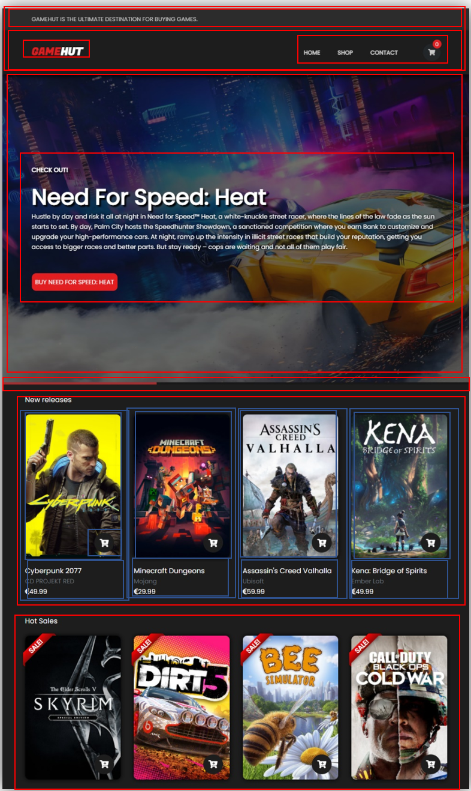

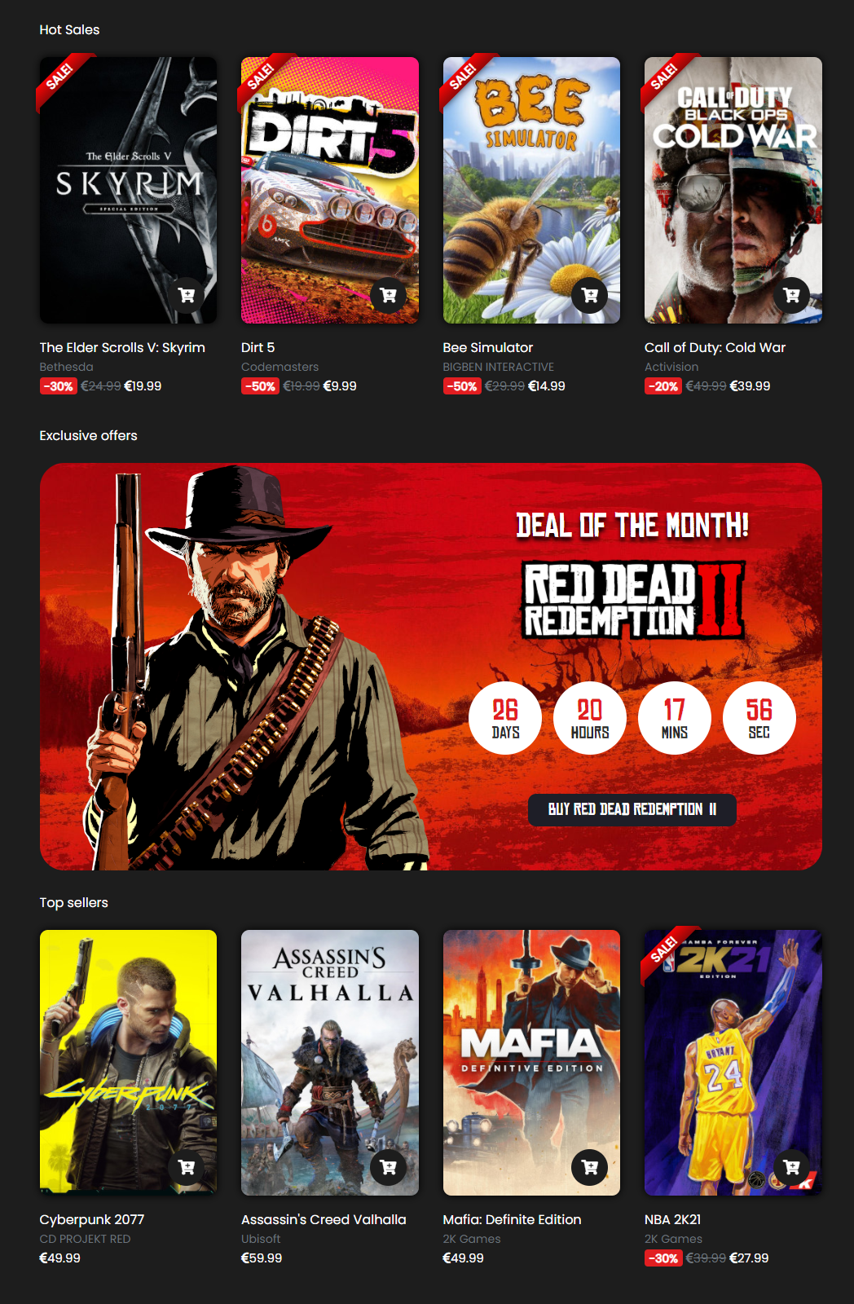

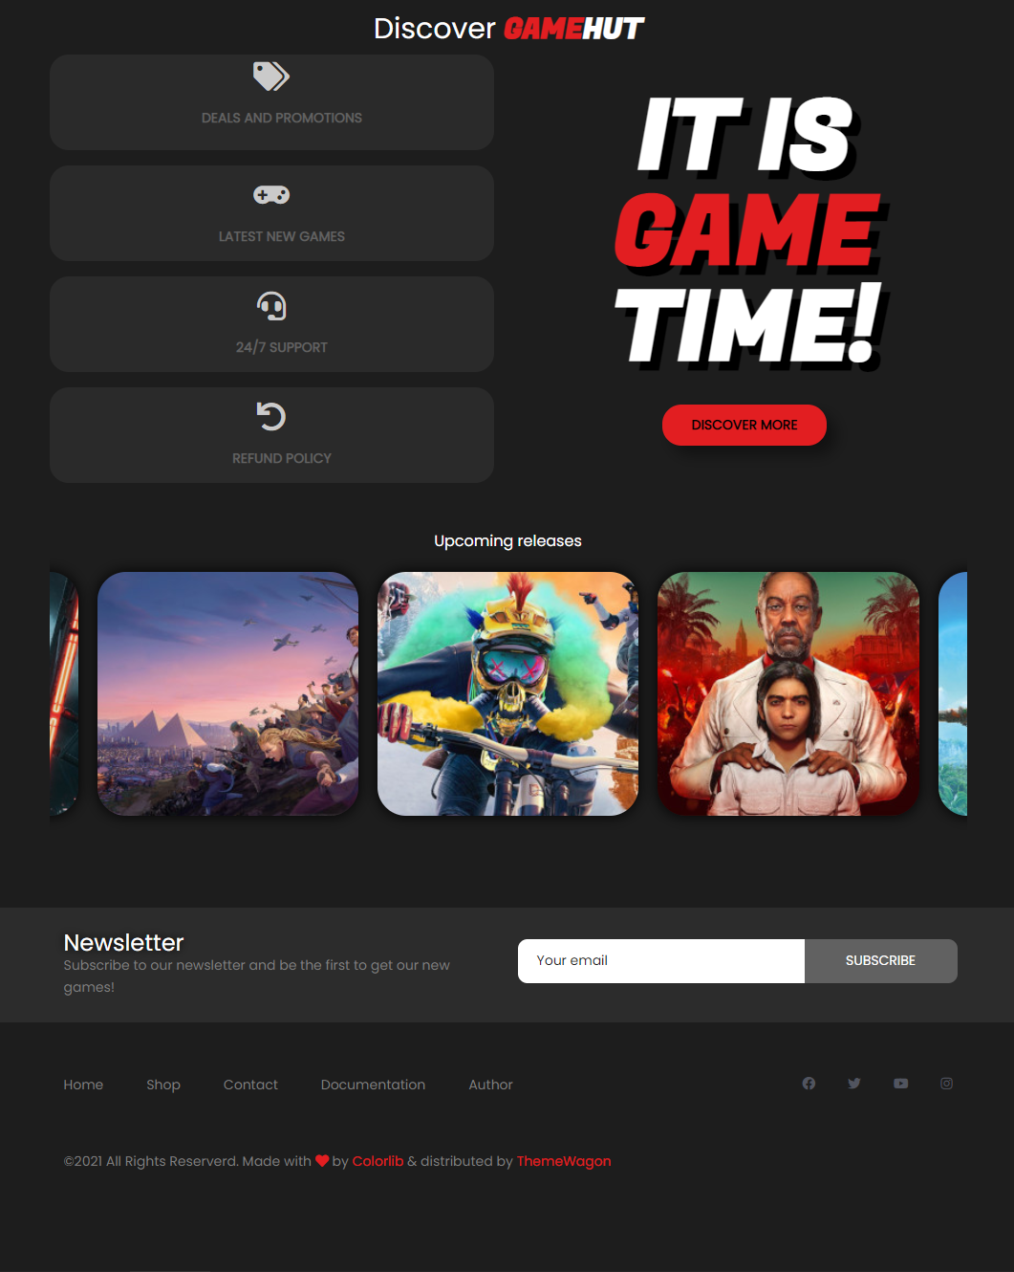

## shop.html

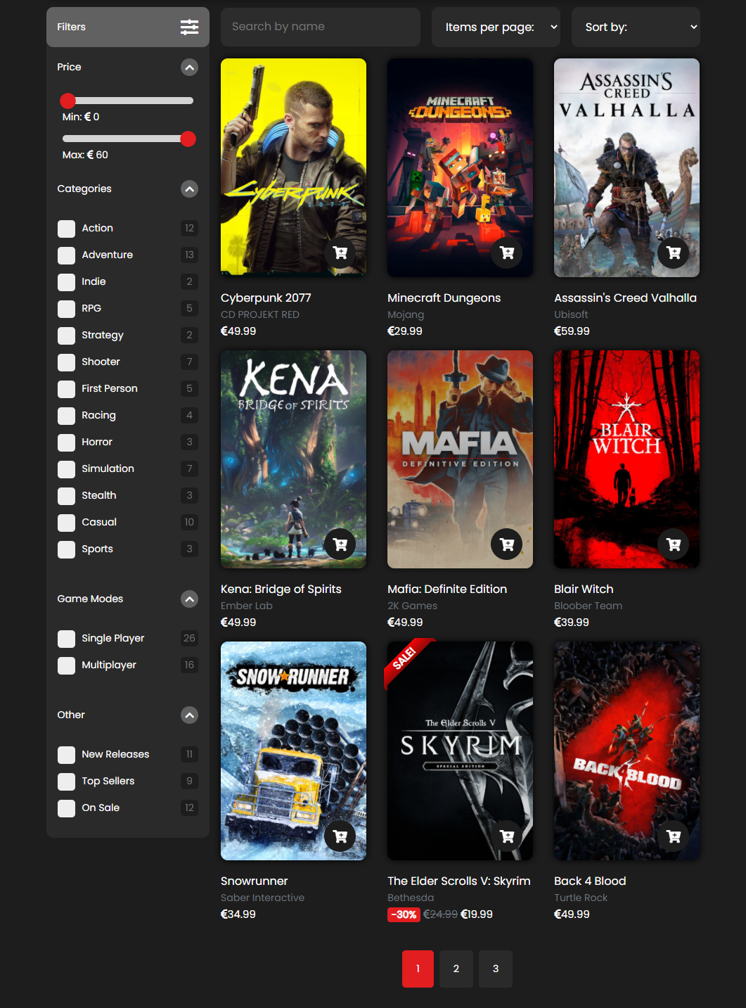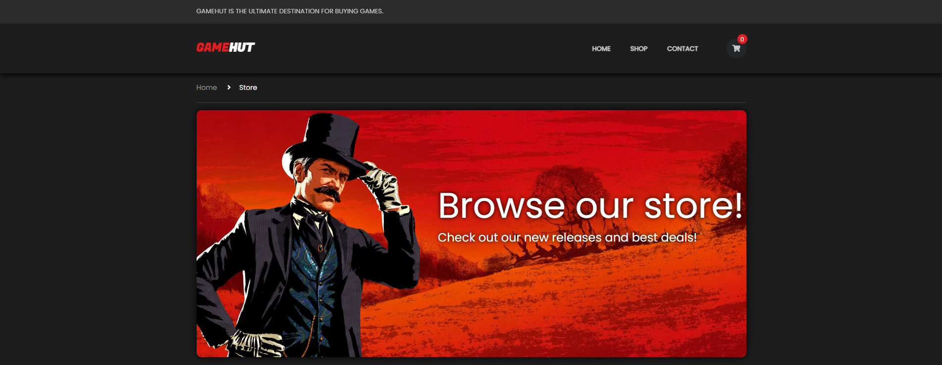

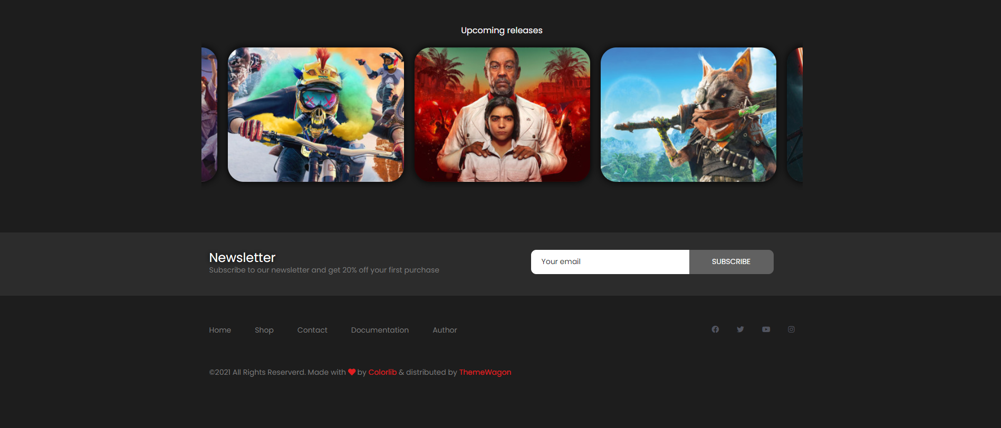

## contact.html

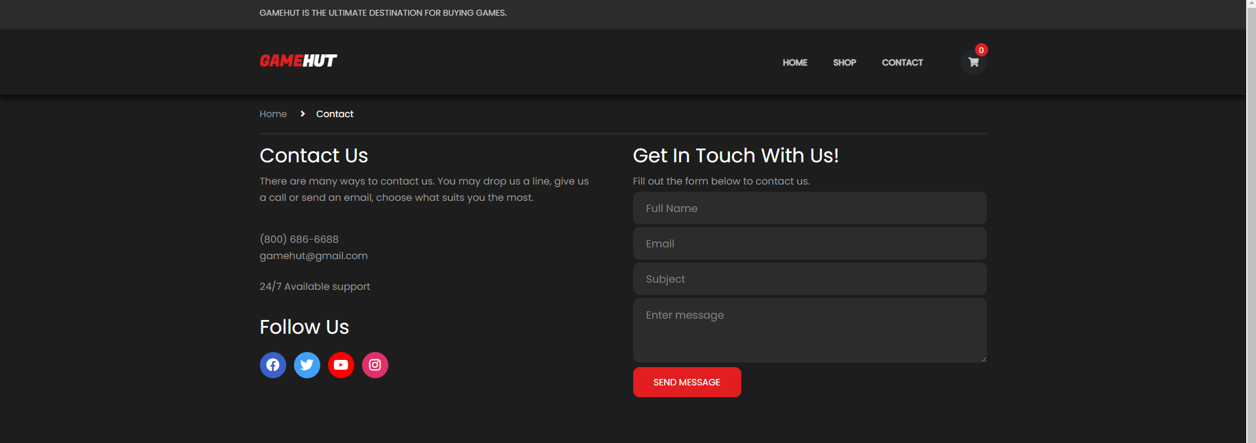



## cart.html

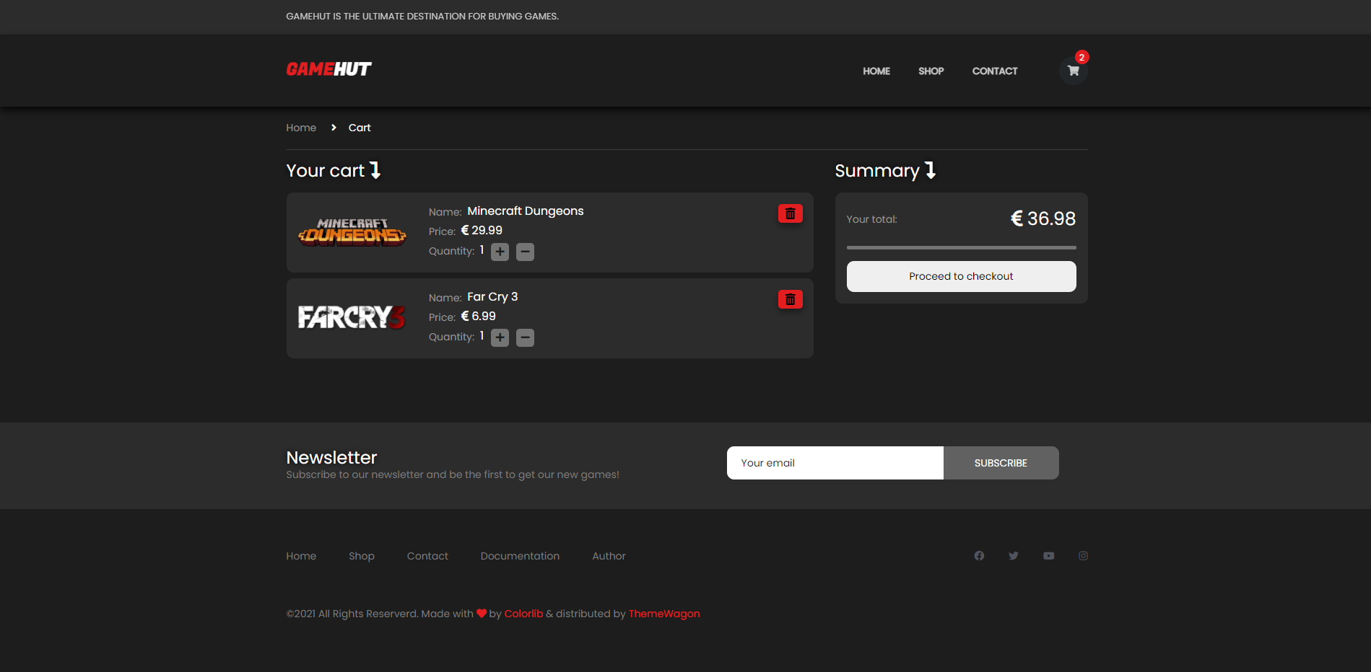

## author.html

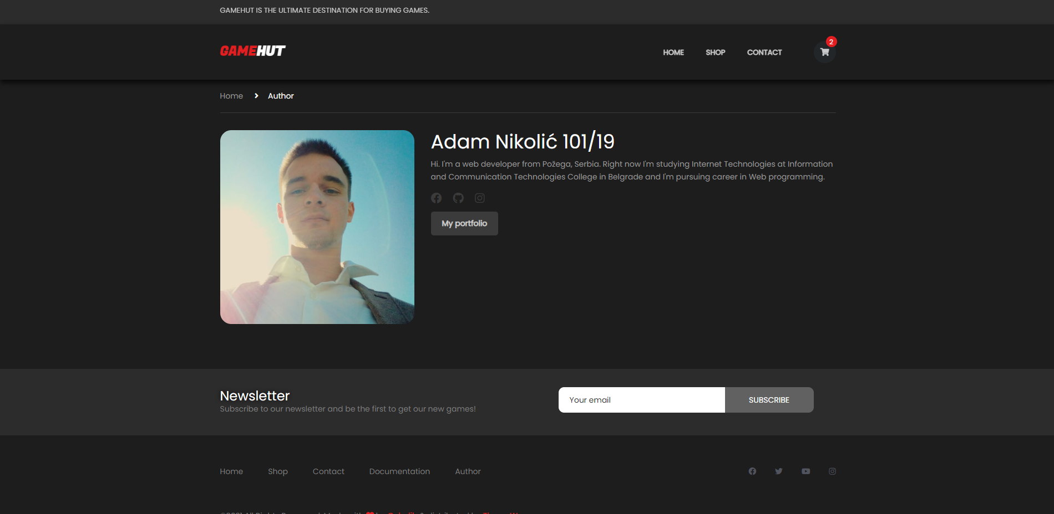

# Organizacija

## Organizaciona šema

# Kodovi

## index.html

<!DOCTYPE html>  
<html lang="en">  
<head>  
 <title>Game Hut - PC Games</title>  
 <meta charset="utf-8">  
 <meta http-equiv="X-UA-Compatible" content="IE=edge">  
 <meta name="description" content="Colo Shop Template">  
 <meta name="viewport" content="width=device-width, initial-scale=1">  
 <link rel="shortcut icon" href="images/favicon.png" type="image/x-icon">  
 <link rel="stylesheet" href="https://use.fontawesome.com/releases/v5.15.1/css/all.css" integrity="sha384-vp86vTRFVJgpjF9jiIGPEEqYqlDwgyBgEF109VFjmqGmIY/Y4HV4d3Gp2irVfcrp" crossorigin="anonymous">  
 <link rel="stylesheet" href="https://cdn.jsdelivr.net/npm/bootstrap@4.6.0/dist/css/bootstrap.min.css" integrity="sha384-B0vP5xmATw1+K9KRQjQERJvTumQW0nPEzvF6L/Z6nronJ3oUOFUFpCjEUQouq2+l" crossorigin="anonymous">  
 <link rel="stylesheet" type="text/css" href="owlcarousel/owl.carousel.min.css"/>  
 <link rel="stylesheet" type="text/css" href="styles/main_styles.css">  
 <link rel="stylesheet" type="text/css" href="styles/responsive.css">  
</head>  
  
<body>  
 <div class="loader-flex-fix">  
 <div class="loader-wrapper">  
 <div class="loader"></div>  
 </div>  
 </div>  
  
<div class="super_container">  
  
 <!-- Header -->  
  
 <header class="header trans_300">  
  
 <!-- Top Navigation -->  
  
 <div class="top_nav">  
 <div class="container">  
 <div class="row">  
 <div class="col-md-6">  
 <div class="top_nav_left">Gamehut is the ultimate destination for buying games.</div>  
 </div>  
 <div class="col-md-6 text-right">  
   
 </div>  
 </div>  
 </div>  
 </div>  
  
 <!-- Main Navigation -->  
  
 <div class="main_nav_container">  
 <div class="container">  
 <div class="row">  
 <div class="col-lg-12 text-right">  
 <div class="logo_container">  
 <a href="index.html">game<span>hut</span></a>  
 </div>  
 <nav class="navbar">  
 <ul class="navbar_menu">  
  
 </ul>  
 <ul class="navbar_user">  
   
 <li class="checkout">  
 <a href="cart.html">  
 <i class="fa fa-shopping-cart" aria-hidden="true"></i>  
 <span id="checkout_items" class="checkout_items"></span>  
 </a>  
 </li>  
 </ul>  
 <div class="hamburger_container">  
 <i class="fa fa-bars" aria-hidden="true"></i>  
 </div>  
 </nav>  
 </div>  
 </div>  
 </div>  
 </div>  
  
 </header>  
  
 <div class="fs_menu_overlay"></div>  
 <div class="hamburger_menu">  
 <div class="hamburger_close"><i class="fa fa-times" aria-hidden="true"></i></div>  
 <div class="hamburger_menu_content text-right">  
 <ul class="menu_top_nav">  
  
 </ul>  
 </div>  
 </div>  
  
 <!-- Slider -->  
  
 <div class="main_slider">  
 <div id="transparent"></div>  
 <div id="slider">  
  
 </div>  
  
 <div class="progress">  
 <div id="progressBar"></div>  
 </div>  
 </div>  
  
  
 <div class="banner">  
 <div class="container">  
 <div class="row d-flex justify-content-between flex-column" id="new">  
 <div class="col-12 pl-0 pb-3"><h5>New releases</h5></div>  
 <div class="col-12 p-0">  
 <div id="newReleases">  
  
 </div>  
 </div>  
   
 </div>  
 </div>  
 </div>  
 <div class="banner">  
 <div class="container">  
 <div class="row d-flex justify-content-between flex-column">  
 <div class="col-12 pl-0 pb-3">  
 <h5>Hot Sales</h5>  
 </div>  
 <div class="col-12 p-0">  
 <div id="hotSales"></div>  
 </div>  
   
 </div>  
 </div>  
 </div>  
 <div class="new_arrivals mt-4 pl-3 pr-3">  
 <div class="container">  
 <div class="row">  
 <div class="col-12 pl-0 pb-3">  
 <h5>Exclusive offers </h5>  
 </div>  
 </div>  
 <div class="row align-items-center" id="box">  
 <div class="deal_ofthe_week">  
 <div class="row">  
 <div class="col-lg-6">  
 <div class="deal_ofthe_week_img">  
 <img src="images/deal_week_guy.png" class="img-fluid" alt="guy1880">  
 </div>  
 </div>  
 <div class="col-lg-6 text-right deal_ofthe_week_col">  
 <div class="deal_ofthe_week_content d-flex flex-column align-items-center justify-content-center">  
 <div class="section_title d-flex flex-column align-items-center">  
 <h2 class="mb-3">Deal of the month!</h2>  
 <img src="images/rdr2_logo.png" alt="logo">  
 </div>  
 <ul class="timer mt-5">  
 <li class="d-inline-flex flex-column justify-content-center align-items-center">  
 <div id="day" class="timer_num"></div>  
 <div class="timer_unit">Days</div>  
 </li>  
 <li class="d-inline-flex flex-column justify-content-center align-items-center">  
 <div id="hour" class="timer_num"></div>  
 <div class="timer_unit">Hours</div>  
 </li>  
 <li class="d-inline-flex flex-column justify-content-center align-items-center">  
 <div id="minute" class="timer_num"></div>  
 <div class="timer_unit">Mins</div>  
 </li>  
 <li class="d-inline-flex flex-column justify-content-center align-items-center">  
 <div id="second" class="timer_num"></div>  
 <div class="timer_unit">Sec</div>  
 </li>  
 </ul>  
 <a href="shop.html" class="mt-5"><div class="red_button deal_ofthe_week_button d-flex justify-content-center align-items-center flex-row">Buy Red Dead Redemption <span class="pl-2">II</span> </div></a>  
 </div>  
 </div>  
 </div>  
 </div>  
 </div>  
 </div>  
 </div>  
 <div class="banner">  
 <div class="container">  
 <div class="row d-flex justify-content-between flex-column">  
 <div class="col-12 pl-0 pb-3">  
 <h5>Top sellers</h5>  
 </div>  
 <div class="col-12 p-0">  
 <div id="topSellers"></div>  
 </div>  
   
 </div>  
 </div>  
 </div>  
 <div class="benefit">  
 <div class="container p-3 p-sm-0">  
 <div class="row">  
 <div class="col">  
 <h1 class="text-center colorH1Span">Discover <span class="text-uppercase font-weight-bold">game</span><span class="text-uppercase font-weight-bold">Hut</span></h1>  
 </div>  
 </div>  
 <div class="row row-cols-2">  
 <div class="col-12 col-md-6">  
 <div class="row row-cols-1">  
 <div class="col benefit_col mb-3">  
 <div class="benefit-clip"></div>  
 <div class="benefit_item d-flex flex-column align-items-center justify-content-center">  
 <div class="benefit_icon pb-3"><i class="fas fa-tags"></i></div>  
 <div class="benefit_content">  
 <h6>Deals and promotions</h6>  
 <p></p>  
 </div>  
 </div>  
 </div>  
 <div class="col benefit_col mb-3">  
 <div class="benefit-clip"></div>  
 <div class="benefit_item d-flex flex-column align-items-center justify-content-center">  
 <div class="benefit_icon pb-3"><i class="fas fa-gamepad"></i></div>  
 <div class="benefit_content">  
 <h6>Latest new games</h6>  
 </div>  
 </div>  
 </div>  
 <div class="col benefit_col mb-3">  
 <div class="benefit-clip"></div>  
 <div class="benefit_item d-flex flex-column align-items-center justify-content-center">  
 <div class="benefit_icon pb-3"><i class="fas fa-headset"></i></div>  
 <div class="benefit_content">  
 <h6>24/7 support</h6>  
 </div>  
 </div>  
 </div>  
 <div class="col benefit_col">  
 <div class="benefit-clip"></div>  
 <div class="benefit_item d-flex flex-column align-items-center justify-content-center">  
 <div class="benefit_icon pb-3"><i class="fas fa-undo"></i></div>  
 <div class="benefit_content">  
 <h6>Refund policy</h6>  
 </div>  
 </div>  
 </div>  
 </div>  
 </div>  
 <div class="col-12 col-md-6 discover d-flex justify-content-center align-items-center flex-column-reverse">  
 <button type="button" id="btnDiscover">DISCOVER MORE</button>  
 <h1 class="game mt-5 mt-md-0">IT IS <span>GAME</span><span></span> TIME!</h1>  
 </div>  
   
 </div>  
 </div>  
 </div>  
  
 <!-- Upcoming -->  
  
 <div class="upcoming">  
 <div class="container">  
 <div class="row">  
 <div class="col text-center">  
 <div class="section_title">  
 <h5>Upcoming releases</h5>  
 </div>  
 </div>  
 </div>  
 <div class="row coming-soon">  
 </div>  
 </div>  
 </div>  
  
 <!-- Newsletter -->  
  
 <div class="newsletter">  
 <div class="container">  
 <div class="row">  
 <div class="col-lg-6">  
 <div class="newsletter_text d-flex flex-column justify-content-center align-items-lg-start align-items-md-center text-center text-lg-left">  
 <h4>Newsletter</h4>  
 <p>Subscribe to our newsletter and be the first to get our new games!</p>  
 </div>  
 </div>  
 <div class="col-lg-6 d-flex justify-content-center align-items-center">  
 <form method="POST" id="newsletter_form" class="d-flex justify-content-center align-items-center flex-column">  
 <div class="newsletter_form d-flex flex-md-row flex-column flex-xs-column align-items-center justify-content-lg-end justify-content-center">  
 <input id="newsletter_email" type="email" placeholder="Your email">  
 <input id="newsletter_submit" type="submit" class="newsletter_submit_btn trans_300" value="Subscribe">  
 </div>  
 <span class="err newsletterErr text-center pb-2 pb-lg-0 pt-lg-2 pt-0"></span>  
 </form>  
 </div>  
 </div>  
 </div>  
 </div>  
  
 <!-- Footer -->  
  
 <footer class="footer">  
 <div class="container">  
 <div class="row">  
 <div class="col-lg-7">  
 <div class="footer_nav_container d-flex flex-sm-row flex-column align-items-center justify-content-lg-start justify-content-center text-center">  
 <ul class="footer_nav">  
  
 </ul>  
 </div>  
 </div>  
 <div class="col-lg-5">  
 <div class="footer_social d-flex flex-row align-items-center justify-content-lg-end justify-content-center">  
 <ul>  
 <li><a href="https://www.facebook.com"><i class="fab fa-facebook"></i></a></li>  
 <li><a href="https://www.twitter.com"><i class="fab fa-twitter"></i></a></li>  
 <li><a href="https://www.youtube.com"><i class="fab fa-youtube"></i></a></li>  
 <li><a href="https://www.instagram.com"><i class="fab fa-instagram"></i></a></li>  
 </ul>  
 </div>  
 </div>  
 </div>  
 <div class="row">  
 <div class="col-lg-12">  
 <div class="footer_nav_container">  
 <div class="cr">&copy;2021 All Rights Reserverd. Made with <i class="fas fa-heart"></i> by <a href="#">Colorlib</a> &amp; distributed by <a href="https://themewagon.com">ThemeWagon</a></div>  
 </div>  
 </div>  
 </div>  
 </div>  
 </footer>  
 <div id="cookie-wrapper">  
 <div id="cookie-notice" class="p-2 d-flex justify-content-around align-items-center flex-column flex-lg-row">  
 <p class="text-center m-0 mb-3 mb-lg-0">We use cookies to provide you with a better experience. By continuing to use our site you accept our <a href="#!">cookie policy.</a></p>  
 <button type="button" id="cookie-accept">I understand</button>  
 </div>  
 </div>  
</div>  
  
<script src="https://code.jquery.com/jquery-3.5.1.min.js" integrity="sha256-9/aliU8dGd2tb6OSsuzixeV4y/faTqgFtohetphbbj0=" crossorigin="anonymous"></script>  
<script src="https://cdn.jsdelivr.net/npm/bootstrap@4.6.0/dist/js/bootstrap.bundle.min.js" integrity="sha384-Piv4xVNRyMGpqkS2by6br4gNJ7DXjqk09RmUpJ8jgGtD7zP9yug3goQfGII0yAns" crossorigin="anonymous"></script>  
<script type="text/javascript" src="owlcarousel/owl.carousel.min.js"></script>  
<script src="js/custom.js"></script>  
</body>  
  
</html>

## shop.html

<!DOCTYPE html>  
<html lang="en">  
<head>  
<title>Game Hut - Store</title>  
<meta charset="utf-8">  
<meta http-equiv="X-UA-Compatible" content="IE=edge">  
<meta name="description" content="Colo Shop Template">  
<meta name="viewport" content="width=device-width, initial-scale=1">  
<link rel="shortcut icon" href="images/favicon.png" type="image/x-icon">  
<link rel="stylesheet" href="https://cdn.jsdelivr.net/npm/bootstrap@4.6.0/dist/css/bootstrap.min.css" integrity="sha384-B0vP5xmATw1+K9KRQjQERJvTumQW0nPEzvF6L/Z6nronJ3oUOFUFpCjEUQouq2+l" crossorigin="anonymous">  
<link rel="stylesheet" href="https://use.fontawesome.com/releases/v5.15.1/css/all.css" integrity="sha384-vp86vTRFVJgpjF9jiIGPEEqYqlDwgyBgEF109VFjmqGmIY/Y4HV4d3Gp2irVfcrp" crossorigin="anonymous">  
<link rel="stylesheet" type="text/css" href="owlcarousel/owl.carousel.min.css"/>  
<link rel="stylesheet" type="text/css" href="styles/main_styles.css">  
<link rel="stylesheet" type="text/css" href="styles/responsive.css">  
</head>  
  
<body>  
<div class="loader-flex-fix">  
 <div class="loader-wrapper">  
 <div class="loader"></div>  
 </div>  
</div>  
<div class="super_container">  
  
 <!-- Header -->  
  
 <header class="header trans_300">  
  
 <!-- Top Navigation -->  
  
 <div class="top_nav">  
 <div class="container">  
 <div class="row">  
 <div class="col-md-6">  
 <div class="top_nav_left">Gamehut is the ultimate destination for buying games.</div>  
 </div>  
 <div class="col-md-6 text-right">  
 <div class="top_nav_right">  
 <ul class="top_nav_menu">  
  
   
 </ul>  
 </div>  
 </div>  
 </div>  
 </div>  
 </div>  
  
 <!-- Main Navigation -->  
  
 <div class="main_nav_container">  
 <div class="container">  
 <div class="row">  
 <div class="col-lg-12 text-right">  
 <div class="logo_container">  
 <a href="#">game<span>hut</span></a>  
 </div>  
 <nav class="navbar">  
 <ul class="navbar_menu">  
  
 </ul>  
 <ul class="navbar_user">  
 <li class="checkout">  
 <a href="cart.html">  
 <i class="fa fa-shopping-cart" aria-hidden="true"></i>  
 <span id="checkout_items" class="checkout_items"></span>  
 </a>  
 </li>  
 </ul>  
 <div class="hamburger_container">  
 <i class="fa fa-bars" aria-hidden="true"></i>  
 </div>  
 </nav>  
 </div>  
 </div>  
 </div>  
 </div>  
  
 </header>  
  
 <div class="fs_menu_overlay"></div>  
  
 <!-- Hamburger Menu -->  
  
 <div class="hamburger_menu">  
 <div class="hamburger_close"><i class="fa fa-times" aria-hidden="true"></i></div>  
 <div class="hamburger_menu_content text-right">  
 <ul class="menu_top_nav">  
  
 </ul>  
 </div>  
 </div>  
  
 <div class="container breadcrumbs_container">  
 <div class="row">  
 <div class="col">  
 <!-- Breadcrumbs -->  
 <div class="breadcrumbs d-flex flex-row align-items-center">  
 <ul>  
 <li><a href="index.html">Home</a></li>  
 <li class="active"><a href="shop.html"><i class="fa fa-angle-right" aria-hidden="true"></i>Store</a></li>  
 </ul>  
 </div>  
  
 </div>  
 </div>  
 </div>  
 <div class="container">  
 <div class="row m-0">  
 <div class="col-12" id="store-banner">  
 <img src="images/store_banner.png" class="img-fluid" alt="guy_with_hat_tipping">  
 <div>  
 <h1>Browse our store!</h1>  
 <h4>Check out our new releases and best deals!</h4>  
 </div>  
 </div>  
 </div>  
 </div>  
 <div class="container">  
 <div class="row m-0">  
 <div class="col-12 col-lg-3 p-0 mt-0 mt-lg-3" id="filter-wrapper">  
 <div id="filter">  
 <span id="filterBg" class="d-flex justify-content-between align-items-center p-3">  
 <span>Filters</span>  
 <i class="fas fa-sliders-h"></i>  
 </span>   
 <div id="price-container" class="d-block">  
 <span class="d-flex justify-content-between align-items-center p-3 hoverFilter" id="priceToggle">  
 <span>Price</span>  
 <span class="circ d-flex justify-content-center align-items-center"><i class="fas fa-chevron-up"></i></span>  
 </span>  
 <div class="pt-2" id="priceRange">  
 <div class="slidecontainer mx-auto">  
 <form action="" method="GET">  
 <input type="range" min="0" max="60" value="0" class="slider" id="priceFrom">  
 <label for="priceFrom" id="labelMin">Min: <i class="fas fa-euro-sign"></i> <output id="from">0</output></label>  
 <input type="range" min="0" max="60" value="60" class="slider" id="priceTo">  
 <label for="priceTo" id="labelMax">Max: <i class="fas fa-euro-sign"></i> <output id="to">60</output></label>  
 </form>  
 </div>  
 </div>  
   
 </div>  
 <div id="categories-container" class="d-block">  
 <span id="filterCat" class="d-flex justify-content-between align-items-center p-3 hoverFilter">  
 <span>Categories</span>  
 <span class="circ d-flex justify-content-center align-items-center"><i class="fas fa-chevron-up"></i></span>  
 </span>  
 <ul class="whiteChb" id="categoryChb">  
   
 </ul>  
 </div>  
 <div id="more-filters-container" class="d-block">  
 <span id="more-filters" class="d-flex justify-content-between align-items-center p-3 hoverFilter">  
 <span>Game Modes</span>  
 <span class="circ d-flex justify-content-center align-items-center"><i class="fas fa-chevron-up"></i></span>  
 </span>  
 <ul id="mode" class="whiteChb">  
   
 </ul>  
 </div>  
 <div id="other-filter-container" class="d-block">  
 <span id="filter-other" class="d-flex justify-content-between align-items-center p-3 hoverFilter">  
 <span>Other</span>  
 <span class="circ d-flex justify-content-center align-items-center"><i class="fas fa-chevron-up"></i></span>  
 </span>  
 <ul class="whiteChb" id="otherFilter">  
   
 </ul>  
 </div>  
 </div>  
   
 </div>  
 <div class="col-12 pr-0 pl-0 pl-lg-3 col-lg-9">  
 <div id="sortBy" class="row m-0 d-flex justify-content-lg-between justify-content-between align-items-center pt-md-3 pb-3">  
 <div class="col-12 col-lg-5 p-0 mb-3 mt-3 mb-lg-0 mt-lg-0 col">  
 <input type="text" name="search" id="search" placeholder="Search by name" class="p-3">  
 </div>  
 <div class="col-12 col-md p-0 mb-3 mb-md-0 px-lg-3 px-0">  
 <select id="numberOfProducts" name="numberOfProducts" class="p-3 w-100 form-control">  
 <option value="9">Items per page: 9</option>  
 <option value="6">Items per page: 6</option>  
 <option value="12">Items per page: 12</option>  
 </select>  
 </div>  
 <div class="col-12 col-md p-0 mb-3 mb-md-0 px-md-3 px-lg-0 ">  
 <div id="sortBtn-wrapper">  
 <select name="sorting" id="sort" class="p-3 w-100 form-control">  
 <option value="0">Sort by:</option>  
 <option value="nameASC">Name: A-Z</option>  
 <option value="nameDESC">Name: Z-A</option>  
 <option value="priceDESC">Price: High to Low</option>  
 <option value="priceASC">Price: Low to High</option>  
 </select>  
 </div>  
 </div>  
 <div id="filter-small" class="col d-lg-none d-block p-0"></div>  
  
  
  
 </div>  
 <div id="products"></div>  
 <div class="col-12 d-flex justify-content-center align-items-center p-4" id="pag">  
   
 </div>  
 </div>  
   
  
 </div>  
   
 </div>  
 <div class="upcoming">  
 <div class="container">  
 <div class="row">  
 <div class="col text-center">  
 <div class="section_title">  
 <h5>Upcoming releases</h5>  
 </div>  
 </div>  
 </div>  
 <div class="row coming-soon">  
 </div>  
 </div>  
 </div>  
 <!-- Newsletter -->  
  
 <div class="newsletter">  
 <div class="container">  
 <div class="row">  
 <div class="col-lg-6">  
 <div class="newsletter_text d-flex flex-column justify-content-center align-items-lg-start align-items-md-center text-center text-lg-left">  
 <h4>Newsletter</h4>  
 <p>Subscribe to our newsletter and get 20% off your first purchase</p>  
 </div>  
 </div>  
 <div class="col-lg-6 d-flex justify-content-center align-items-center">  
 <form id="newsletter_form" class="d-flex justify-content-center align-items-center flex-column">  
 <div class="newsletter_form d-flex flex-md-row flex-column flex-xs-column align-items-center justify-content-lg-end justify-content-center">  
 <input id="newsletter_email" type="email" placeholder="Your email">  
 <input id="newsletter_submit" type="submit" class="newsletter_submit_btn trans_300" value="Subscribe">  
 </div>  
 <span class="err newsletterErr text-center pb-2 pb-lg-0 pt-lg-2 pt-0"></span>  
 </form>  
 </div>  
 </div>  
 </div>  
 </div>  
  
 <!-- Footer -->  
  
 <footer class="footer">  
 <div class="container">  
 <div class="row">  
 <div class="col-lg-7">  
 <div class="footer_nav_container d-flex flex-sm-row flex-column align-items-center justify-content-lg-start justify-content-center text-center text-lg-left">  
 <ul class="footer_nav">  
  
 </ul>  
 </div>  
 </div>  
 <div class="col-lg-5">  
 <div class="footer_social d-flex flex-row align-items-center justify-content-lg-end justify-content-center">  
 <ul>  
 <li><a href="https://www.facebook.com"><i class="fab fa-facebook"></i></a></li>  
 <li><a href="https://www.twitter.com"><i class="fab fa-twitter"></i></a></li>  
 <li><a href="https://www.youtube.com"><i class="fab fa-youtube"></i></a></li>  
 <li><a href="https://www.instagram.com"><i class="fab fa-instagram"></i></a></li>  
 </ul>  
 </div>  
 </div>  
 </div>  
 <div class="row">  
 <div class="col-lg-12">  
 <div class="footer_nav_container">  
 <div class="cr">&copy;2021 All Rights Reserverd. Made with <i class="fas fa-heart"></i> by <a href="#">Colorlib</a> &amp; distributed by <a href="https://themewagon.com">ThemeWagon</a></div>  
 </div>  
 </div>  
 </div>  
 </div>  
 </footer>  
 <div id="cookie-wrapper">  
 <div id="cookie-notice" class="p-2 d-flex justify-content-around align-items-center flex-column flex-lg-row">  
 <p class="text-center m-0 mb-3 mb-lg-0">We use cookies to provide you with a better experience. By continuing to use our site you accept our <a href="#!">cookie policy.</a></p>  
 <button type="button" id="cookie-accept">I understand</button>  
 </div>  
 </div>  
</div>  
  
  
  
  
  
<script src="https://code.jquery.com/jquery-3.5.1.min.js" integrity="sha256-9/aliU8dGd2tb6OSsuzixeV4y/faTqgFtohetphbbj0=" crossorigin="anonymous"></script>  
<script src="https://cdn.jsdelivr.net/npm/bootstrap@4.6.0/dist/js/bootstrap.bundle.min.js" integrity="sha384-Piv4xVNRyMGpqkS2by6br4gNJ7DXjqk09RmUpJ8jgGtD7zP9yug3goQfGII0yAns" crossorigin="anonymous"></script>  
<script type="text/javascript" src="owlcarousel/owl.carousel.min.js"></script>  
<script src="js/custom.js"></script>  
</body>  
  
</html>

## contact.html

<!DOCTYPE html>  
<html lang="en">  
<head>  
<title>Game Hut - Contact Us</title>  
<meta charset="utf-8">  
<meta http-equiv="X-UA-Compatible" content="IE=edge">  
<meta name="description" content="Colo Shop Template">  
<meta name="viewport" content="width=device-width, initial-scale=1">  
<link rel="shortcut icon" href="images/favicon.png" type="image/x-icon">  
<link rel="stylesheet" href="https://cdn.jsdelivr.net/npm/bootstrap@4.6.0/dist/css/bootstrap.min.css" integrity="sha384-B0vP5xmATw1+K9KRQjQERJvTumQW0nPEzvF6L/Z6nronJ3oUOFUFpCjEUQouq2+l" crossorigin="anonymous">  
<link rel="stylesheet" href="https://use.fontawesome.com/releases/v5.15.1/css/all.css" integrity="sha384-vp86vTRFVJgpjF9jiIGPEEqYqlDwgyBgEF109VFjmqGmIY/Y4HV4d3Gp2irVfcrp" crossorigin="anonymous">  
<link rel="stylesheet" type="text/css" href="styles/main_styles.css">  
<link rel="stylesheet" type="text/css" href="styles/responsive.css">  
</head>  
  
<body>  
<div class="loader-flex-fix">  
 <div class="loader-wrapper">  
 <div class="loader"></div>  
 </div>  
</div>  
<div class="super_container">  
  
 <!-- Header -->  
  
 <header class="header trans_300">  
  
 <!-- Top Navigation -->  
  
 <div class="top_nav">  
 <div class="container">  
 <div class="row">  
 <div class="col">  
 <div class="top_nav_left">Gamehut is the ultimate destination for buying games.</div>  
 </div>  
 </div>  
 </div>  
 </div>  
  
 <!-- Main Navigation -->  
  
 <div class="main_nav_container">  
 <div class="container">  
 <div class="row">  
 <div class="col-lg-12 text-right">  
 <div class="logo_container">  
 <a href="#">game<span>hut</span></a>  
 </div>  
 <nav class="navbar">  
 <ul class="navbar_menu">  
  
 </ul>  
 <ul class="navbar_user">  
 <li class="checkout">  
 <a href="cart.html">  
 <i class="fa fa-shopping-cart" aria-hidden="true"></i>  
 <span id="checkout_items" class="checkout_items"></span>  
 </a>  
 </li>  
 </ul>  
 <div class="hamburger_container">  
 <i class="fa fa-bars" aria-hidden="true"></i>  
 </div>  
 </nav>  
 </div>  
 </div>  
 </div>  
 </div>  
  
 </header>  
  
 <div class="fs_menu_overlay"></div>  
  
 <!-- Hamburger Menu -->  
  
 <div class="hamburger_menu">  
 <div class="hamburger_close"><i class="fa fa-times" aria-hidden="true"></i></div>  
 <div class="hamburger_menu_content text-right">  
 <ul class="menu_top_nav">  
  
 </ul>  
 </div>  
 </div>  
  
 <div class="container contact_container">  
 <div class="row">  
 <div class="col">  
  
 <!-- Breadcrumbs -->  
 <div class="breadcrumbs d-flex flex-row align-items-center">  
 <ul>  
 <li><a href="index.html">Home</a></li>  
 <li class="active"><a href="contact.html"><i class="fa fa-angle-right" aria-hidden="true"></i>Contact</a></li>  
 </ul>  
 </div>  
  
 </div>  
 </div>  
 <!-- Contact Us -->  
 <div class="row">  
 <div class="col-lg-6 contact_col">  
 <div class="contact_contents">  
 <h1>Contact Us</h1>  
 <p>There are many ways to contact us. You may drop us a line, give us a call or send an email, choose what suits you the most.</p>  
 <div>  
 <p>(800) 686-6688</p>  
 <p>gamehut@gmail.com</p>  
 </div>  
 <div>  
 <p>24/7 Available support</p>  
 </div>  
 </div>  
  
 <!-- Follow Us -->  
  
 <div class="follow_us_contents">  
 <h1>Follow Us</h1>  
 <ul class="social d-flex flex-row">  
 <li><a href="https://www.facebook.com" style="background-color: #3a61c9"><i class="fab fa-facebook"></i></a></li>  
 <li><a href="https://www.twitter.com" style="background-color: #41a1f6"><i class="fab fa-twitter"></i></a></li>  
 <li><a href="https://www.youtube.com" style="background-color: #ff0000"><i class="fab fa-youtube"></i></a></li>  
 <li><a href="https://www.instagram.com" style="background-color: #E1306C"><i class="fab fa-instagram"></i></a></li>  
 </ul>  
 </div>  
  
 </div>  
  
 <div class="col-lg-6 get_in_touch_col">  
 <div class="get_in_touch_contents">  
 <h1>Get In Touch With Us!</h1>  
 <p>Fill out the form below to contact us.</p>  
 <form method="POST" id="contact">  
 <input id="input_name" class="form_input input_name input_ph my-1" type="text" name="name" placeholder="Full Name">  
 <span class="err name"></span>  
 <input id="input_email" class="form_input input_email input_ph my-1" type="email" name="email" placeholder="Email">  
 <span class="err mail"></span>  
 <input id="input_subject" class="form_input input_subject input_ph my-1" type="text" name="name" placeholder="Subject">  
 <span class="err subject"></span>  
 <textarea id="input_message" class="input_ph input_message" name="message" placeholder="Enter message" rows="3"></textarea>  
 <span class="err message"></span>  
 <div>  
 <input id="review_submit" type="submit" class="red_button message_submit_btn trans_300" value="send message">  
 </div>  
 </form>  
 </div>  
 </div>  
  
 </div>  
 </div>  
  
 <!-- Newsletter -->  
  
 <div class="newsletter">  
 <div class="container">  
 <div class="row">  
 <div class="col-lg-6">  
 <div class="newsletter_text d-flex flex-column justify-content-center align-items-lg-start align-items-md-center text-center text-lg-left">  
 <h4>Newsletter</h4>  
 <p>Subscribe to our newsletter and be the first to get our new games!</p>  
 </div>  
 </div>  
 <div class="col-lg-6 d-flex justify-content-center align-items-center">  
 <form id="newsletter_form" class="d-flex justify-content-center align-items-center flex-column">  
 <div class="newsletter_form d-flex flex-md-row flex-column flex-xs-column align-items-center justify-content-lg-end justify-content-center">  
 <input id="newsletter_email" type="email" placeholder="Your email">  
 <input id="newsletter_submit" type="submit" class="newsletter_submit_btn trans_300" value="Subscribe">  
 </div>  
 <span class="err newsletterErr text-center pb-2 pb-lg-0 pt-lg-2 pt-0"></span>  
 </form>  
 </div>  
 </div>  
 </div>  
 </div>  
  
 <!-- Footer -->  
  
 <footer class="footer">  
 <div class="container">  
 <div class="row">  
 <div class="col-lg-7">  
 <div class="footer_nav_container d-flex flex-sm-row flex-column align-items-center justify-content-lg-start justify-content-center text-center text-lg-left">  
 <ul class="footer_nav">  
  
 </ul>  
 </div>  
 </div>  
 <div class="col-lg-5">  
 <div class="footer_social d-flex flex-row align-items-center justify-content-lg-end justify-content-center">  
 <ul>  
 <li><a href="https://www.facebook.com"><i class="fab fa-facebook"></i></a></li>  
 <li><a href="https://www.twitter.com"><i class="fab fa-twitter"></i></a></li>  
 <li><a href="https://www.youtube.com"><i class="fab fa-youtube"></i></a></li>  
 <li><a href="https://www.instagram.com"><i class="fab fa-instagram"></i></a></li>  
 </ul>  
 </div>  
 </div>  
 </div>  
 <div class="row">  
 <div class="col-lg-12">  
 <div class="footer_nav_container">  
 <div class="cr">&copy;2021 All Rights Reserverd. Made with <i class="fas fa-heart"></i> by <a href="#">Colorlib</a> &amp; distributed by <a href="https://themewagon.com">ThemeWagon</a></div>  
 </div>  
 </div>  
 </div>  
 </div>  
 </footer>  
 <div id="cookie-wrapper">  
 <div id="cookie-notice" class="p-2 d-flex justify-content-around align-items-center flex-column flex-lg-row">  
 <p class="text-center m-0 mb-3 mb-lg-0">We use cookies to provide you with a better experience. By continuing to use our site you accept our <a href="#!">cookie policy.</a></p>  
 <button type="button" id="cookie-accept">I understand</button>  
 </div>  
 </div>  
</div>  
  
<script src="https://code.jquery.com/jquery-3.5.1.min.js" integrity="sha256-9/aliU8dGd2tb6OSsuzixeV4y/faTqgFtohetphbbj0=" crossorigin="anonymous"></script>  
<script src="https://cdn.jsdelivr.net/npm/bootstrap@4.6.0/dist/js/bootstrap.bundle.min.js" integrity="sha384-Piv4xVNRyMGpqkS2by6br4gNJ7DXjqk09RmUpJ8jgGtD7zP9yug3goQfGII0yAns" crossorigin="anonymous"></script>  
<script src="js/custom.js"></script>  
</body>  
  
</html>

## single.html

<!DOCTYPE html>  
<html lang="en">  
<head>  
<title></title> <!-- Dinamicki se ispisuje -->  
<meta charset="utf-8">  
<meta http-equiv="X-UA-Compatible" content="IE=edge">  
<meta name="description" content="Colo Shop Template">  
<meta name="viewport" content="width=device-width, initial-scale=1">  
<link rel="shortcut icon" href="images/favicon.png" type="image/x-icon">  
<link rel="stylesheet" href="https://use.fontawesome.com/releases/v5.15.1/css/all.css" integrity="sha384-vp86vTRFVJgpjF9jiIGPEEqYqlDwgyBgEF109VFjmqGmIY/Y4HV4d3Gp2irVfcrp" crossorigin="anonymous">  
<link rel="stylesheet" href="https://cdn.jsdelivr.net/npm/bootstrap@4.6.0/dist/css/bootstrap.min.css" integrity="sha384-B0vP5xmATw1+K9KRQjQERJvTumQW0nPEzvF6L/Z6nronJ3oUOFUFpCjEUQouq2+l" crossorigin="anonymous">  
<link rel="stylesheet" type="text/css" href="styles/main_styles.css">  
<link rel="stylesheet" type="text/css" href="styles/responsive.css">  
<link rel="stylesheet" type="text/css" href="owlcarousel/owl.carousel.min.css"/>  
</head>  
  
<body>  
<div class="loader-flex-fix">  
 <div class="loader-wrapper">  
 <div class="loader"></div>  
 </div>  
</div>  
<div class="super_container">  
  
 <!-- Header -->  
 <header class="header trans_300">  
  
 <!-- Top Navigation -->  
 <div class="top_nav">  
 <div class="container">  
 <div class="row">  
 <div class="col-md-6">  
 <div class="top_nav_left">Gamehut is the ultimate destination for buying games.</div>  
 </div>  
 </div>  
 </div>  
 </div>  
  
 <!-- Main Navigation -->  
  
 <div class="main_nav_container">  
 <div class="container">  
 <div class="row">  
 <div class="col-lg-12 text-right">  
 <div class="logo_container">  
 <a href="#">Game<span>hut</span></a>  
 </div>  
 <nav class="navbar">  
 <ul class="navbar_menu">  
 <li><a href="index.html">home</a></li>  
 <li><a href="shop.html">store</a></li>  
 <li><a href="contact.html">contact</a></li>  
 </ul>  
 <ul class="navbar_user">  
 <li class="checkout">  
 <a href="cart.html">  
 <i class="fa fa-shopping-cart" aria-hidden="true"></i>  
 <span id="checkout_items" class="checkout_items"></span>  
 </a>  
 </li>  
 </ul>  
 <div class="hamburger_container">  
 <i class="fa fa-bars" aria-hidden="true"></i>  
 </div>  
 </nav>  
 </div>  
 </div>  
 </div>  
 </div>  
  
 </header>  
  
 <div class="fs_menu_overlay"></div>  
  
 <!-- Hamburger Menu -->  
  
 <div class="hamburger_menu">  
 <div class="hamburger_close"><i class="fa fa-times" aria-hidden="true"></i></div>  
 <div class="hamburger_menu_content text-right">  
 <ul class="menu_top_nav">  
  
 </ul>  
 </div>  
 </div>  
   
 <div class="container breadcrumbs_container">  
 <div class="row">  
 <div class="col">  
 <!-- Breadcrumbs -->  
 <div class="breadcrumbs d-flex flex-row align-items-center">  
 <ul>  
 <li><a href="index.html">Home</a></li>  
 <li><a href="shop.html"><i class="fa fa-angle-right" aria-hidden="true"></i>Store</a></li>  
 <li class="active"><a href="#" id="name"><i class="fa fa-angle-right" aria-hidden="true"></i></a></li>  
 </ul>  
 </div>  
  
 </div>  
 </div>  
 </div>  
 <div class="container mb-3">  
 <div class="row" id="logo-game-container">  
 </div>  
 </div>  
 <!-- SCREENSHOTS SECTION -->  
 <div class="container">  
 <div class="row">  
 <div class="col-12 col-md-4 col-lg-3">  
 <h5>Gameplay screenshots</h5>  
 </div>  
 <div class="col-12 col-md-8 col-lg-9 mb-3" id="slika">  
   
 </div>  
 </div>  
 </div>  
 <!-- ABOUT GAME -->  
 <div class="container">  
 <div class="row">  
 <div class="col-12 col-md-4 col-lg-3">  
 <h1 id="gameName">About </h1>  
 </div>  
 <div class="col-12 col-md-8 col-lg-9 mb-3">  
 <ul class="d-flex flex-wrap flex-column p-3" id="about">  
   
 </ul>  
 <div id="infoText" class="p-3">   
 </div>  
 </div>  
 </div>  
 </div>  
 <!-- SYSTEM REQUIREMENTS -->  
 <div class="container">  
 <div class="row" id="sysReq">  
 <div class="col-12 col-md-4 col-lg-3 text-light">  
 <h5>System requirements</h5>  
 </div>  
 <div class="col-12 col-md-8 col-lg-9">  
 <div class="row px-3" >  
 <div class="col-12 m-0 p-0">  
 <h6 class="p-3 mb-3 borderBot d-inline-block reqOutput">Windows</h6>  
 </div>  
 <div class="col-12 col-sm pt-4 reqOutput">  
 <h6 class="mb-4">Minimum requirements</h6>  
 <ul id="minimum">  
   
 </ul>  
 </div>  
 <div class="col-12 col-sm pt-4 reqOutput">  
 <h6 class="mb-4">Recommended requirements</h6>  
 <ul id="recommended">  
   
 </ul>  
 </div>  
 </div>  
 </div>  
 </div>  
 </div>  
 <!-- Newsletter -->  
 <div class="newsletter">  
 <div class="container">  
 <div class="row">  
 <div class="col-lg-6">  
 <div class="newsletter_text d-flex flex-column justify-content-center align-items-lg-start align-items-md-center text-center text-lg-left">  
 <h4>Newsletter</h4>  
 <p>Subscribe to our newsletter and be the first to get our new games!</p>  
 </div>  
 </div>  
 <div class="col-lg-6 d-flex justify-content-center align-items-center">  
 <form id="newsletter_form" class="d-flex justify-content-center align-items-center flex-column">  
 <div class="newsletter_form d-flex flex-md-row flex-column flex-xs-column align-items-center justify-content-lg-end justify-content-center">  
 <input id="newsletter_email" type="email" placeholder="Your email">  
 <input id="newsletter_submit" type="submit" class="newsletter_submit_btn trans_300" value="Subscribe">  
 </div>  
 <span class="err newsletterErr text-center pb-2 pb-lg-0 pt-lg-2 pt-0"></span>  
 </form>  
 </div>  
 </div>  
 </div>  
 </div>  
  
 <!-- Footer -->  
  
 <footer class="footer">  
 <div class="container">  
 <div class="row">  
 <div class="col-lg-7">  
 <div class="footer_nav_container d-flex flex-sm-row flex-column align-items-center justify-content-lg-start justify-content-center text-center">  
 <ul class="footer_nav">  
  
 </ul>  
 </div>  
 </div>  
 <div class="col-lg-5">  
 <div class="footer_social d-flex flex-row align-items-center justify-content-lg-end justify-content-center">  
 <ul>  
 <li><a href="https://www.facebook.com"><i class="fab fa-facebook"></i></a></li>  
 <li><a href="https://www.twitter.com"><i class="fab fa-twitter"></i></a></li>  
 <li><a href="https://www.youtube.com"><i class="fab fa-youtube"></i></a></li>  
 <li><a href="https://www.instagram.com"><i class="fab fa-instagram"></i></a></li>  
 </ul>  
 </div>  
 </div>  
 </div>  
 <div class="row">  
 <div class="col-lg-12">  
 <div class="footer_nav_container">  
 <div class="cr">&copy;2021 All Rights Reserverd. Made with <i class="fas fa-heart"></i> by <a href="#">Colorlib</a> &amp; distributed by <a href="https://themewagon.com">ThemeWagon</a></div>  
 </div>  
 </div>  
 </div>  
 </div>  
 </footer>  
 <div id="cookie-wrapper">  
 <div id="cookie-notice" class="p-2 d-flex justify-content-around align-items-center flex-column flex-lg-row">  
 <p class="text-center m-0 mb-3 mb-lg-0">We use cookies to provide you with a better experience. By continuing to use our site you accept our <a href="#!">cookie policy.</a></p>  
 <button type="button" id="cookie-accept">I understand</button>  
 </div>  
 </div>  
</div>  
 <script src="https://code.jquery.com/jquery-3.5.1.min.js" integrity="sha256-9/aliU8dGd2tb6OSsuzixeV4y/faTqgFtohetphbbj0=" crossorigin="anonymous"></script>  
 <script src="https://cdn.jsdelivr.net/npm/bootstrap@4.6.0/dist/js/bootstrap.bundle.min.js" integrity="sha384-Piv4xVNRyMGpqkS2by6br4gNJ7DXjqk09RmUpJ8jgGtD7zP9yug3goQfGII0yAns" crossorigin="anonymous"></script>  
 <script type="text/javascript" src="owlcarousel/owl.carousel.min.js"></script>  
 <script src="js/custom.js"></script>  
  
</body>  
  
</html>

## author.html

<!DOCTYPE html>  
<html lang="en">  
<head>  
 <title>Game Hut - Author</title>  
 <meta charset="utf-8">  
 <meta http-equiv="X-UA-Compatible" content="IE=edge">  
 <meta name="description" content="Colo Shop Template">  
 <meta name="viewport" content="width=device-width, initial-scale=1">  
 <link rel="shortcut icon" href="images/favicon.png" type="image/x-icon">  
 <link rel="stylesheet" href="https://cdn.jsdelivr.net/npm/bootstrap@4.6.0/dist/css/bootstrap.min.css" integrity="sha384-B0vP5xmATw1+K9KRQjQERJvTumQW0nPEzvF6L/Z6nronJ3oUOFUFpCjEUQouq2+l" crossorigin="anonymous">  
 <link rel="stylesheet" href="https://use.fontawesome.com/releases/v5.15.1/css/all.css" integrity="sha384-vp86vTRFVJgpjF9jiIGPEEqYqlDwgyBgEF109VFjmqGmIY/Y4HV4d3Gp2irVfcrp" crossorigin="anonymous">  
 <link rel="stylesheet" type="text/css" href="styles/main_styles.css">  
 <link rel="stylesheet" type="text/css" href="styles/responsive.css">  
</head>  
  
<body>  
<div class="loader-flex-fix">  
 <div class="loader-wrapper">  
 <div class="loader"></div>  
 </div>  
</div>  
<div class="super_container">  
  
 <!-- Header -->  
  
 <header class="header trans_300">  
  
 <!-- Top Navigation -->  
  
 <div class="top_nav">  
 <div class="container">  
 <div class="row">  
 <div class="col">  
 <div class="top_nav_left">Gamehut is the ultimate destination for buying games.</div>  
 </div>  
 </div>  
 </div>  
 </div>  
  
 <!-- Main Navigation -->  
  
 <div class="main_nav_container">  
 <div class="container">  
 <div class="row">  
 <div class="col-lg-12 text-right">  
 <div class="logo_container">  
 <a href="#">game<span>hut</span></a>  
 </div>  
 <nav class="navbar">  
 <ul class="navbar_menu">  
  
 </ul>  
 <ul class="navbar_user">  
 <li class="checkout">  
 <a href="cart.html">  
 <i class="fa fa-shopping-cart" aria-hidden="true"></i>  
 <span id="checkout_items" class="checkout_items"></span>  
 </a>  
 </li>  
 </ul>  
 <div class="hamburger_container">  
 <i class="fa fa-bars" aria-hidden="true"></i>  
 </div>  
 </nav>  
 </div>  
 </div>  
 </div>  
 </div>  
  
 </header>  
  
 <div class="fs_menu_overlay"></div>  
  
 <!-- Hamburger Menu -->  
  
 <div class="hamburger_menu">  
 <div class="hamburger_close"><i class="fa fa-times" aria-hidden="true"></i></div>  
 <div class="hamburger_menu_content text-right">  
 <ul class="menu_top_nav">  
  
 </ul>  
 </div>  
 </div>  
  
 <div class="container contact_container">  
 <div class="row">  
 <div class="col">  
  
 <!-- Breadcrumbs -->  
 <div class="breadcrumbs d-flex flex-row align-items-center">  
 <ul>  
 <li><a href="index.html">Home</a></li>  
 <li class="active"><a href="author.html"><i class="fa fa-angle-right" aria-hidden="true"></i>Author</a></li>  
 </ul>  
 </div>  
  
 </div>  
 </div>  
 <!-- Contact Us -->  
 <div class="row my-3" id="autor">  
 <div class="col-9 col-md-4 mb-3 mb-md-0">  
 <img src="images/autor.jpg" alt="author" class="img-fluid"/>  
 </div>  
 <div class="col-12 col-md-8">  
 <h1>Adam Nikolić 101/19</h1>  
 <p>Hi. I'm a web developer from Požega, Serbia. Right now I'm studying Internet Technologies at Information and Communication Technologies College in Belgrade and I'm pursuing career in Web programming.</p>  
 <ul class="d-flex flex-row align-items-center justify-content-start">  
 <li><a href="https://www.facebook.com"><i class="fab fa-facebook"></i></a></li>  
 <li><a href="https://www.github.com/adamnik101"><i class="fab fa-github"></i></a></li>  
 <li><a href="https://www.instagram.com/adamnikk"><i class="fab fa-instagram"></i></a></li>  
 </ul>  
 <a href="https://adamnik101.github.io/adamportfolio/index.html" target="_blank"><button type="button">My portfolio</button> </a>  
 </div>  
  
 </div>  
 </div>  
  
 <!-- Newsletter -->  
  
 <div class="newsletter">  
 <div class="container">  
 <div class="row">  
 <div class="col-lg-6">  
 <div class="newsletter_text d-flex flex-column justify-content-center align-items-lg-start align-items-md-center text-center text-lg-left">  
 <h4>Newsletter</h4>  
 <p>Subscribe to our newsletter and be the first to get our new games!</p>  
 </div>  
 </div>  
 <div class="col-lg-6 d-flex justify-content-center align-items-center">  
 <form id="newsletter_form" class="d-flex justify-content-center align-items-center flex-column">  
 <div class="newsletter_form d-flex flex-md-row flex-column flex-xs-column align-items-center justify-content-lg-end justify-content-center">  
 <input id="newsletter_email" type="email" placeholder="Your email">  
 <input id="newsletter_submit" type="submit" class="newsletter_submit_btn trans_300" value="Subscribe">  
 </div>  
 <span class="err newsletterErr text-center pb-2 pb-lg-0 pt-lg-2 pt-0"></span>  
 </form>  
 </div>  
 </div>  
 </div>  
 </div>  
  
 <!-- Footer -->  
  
 <footer class="footer">  
 <div class="container">  
 <div class="row">  
 <div class="col-lg-7">  
 <div class="footer_nav_container d-flex flex-sm-row flex-column align-items-center justify-content-lg-start justify-content-center text-center text-lg-left">  
 <ul class="footer_nav">  
  
 </ul>  
 </div>  
 </div>  
 <div class="col-lg-5">  
 <div class="footer_social d-flex flex-row align-items-center justify-content-lg-end justify-content-center">  
 <ul>  
 <li><a href="https://www.facebook.com"><i class="fab fa-facebook"></i></a></li>  
 <li><a href="https://www.twitter.com"><i class="fab fa-twitter"></i></a></li>  
 <li><a href="https://www.youtube.com"><i class="fab fa-youtube"></i></a></li>  
 <li><a href="https://www.instagram.com"><i class="fab fa-instagram"></i></a></li>  
 </ul>  
 </div>  
 </div>  
 </div>  
 <div class="row">  
 <div class="col-lg-12">  
 <div class="footer_nav_container">  
 <div class="cr">&copy;2021 All Rights Reserverd. Made with <i class="fas fa-heart"></i> by <a href="#">Colorlib</a> &amp; distributed by <a href="https://themewagon.com">ThemeWagon</a></div>  
 </div>  
 </div>  
 </div>  
 </div>  
 </footer>  
 <div id="cookie-wrapper">  
 <div id="cookie-notice" class="p-2 d-flex justify-content-around align-items-center flex-column flex-lg-row">  
 <p class="text-center m-0 mb-3 mb-lg-0">We use cookies to provide you with a better experience. By continuing to use our site you accept our <a href="#!">cookie policy.</a></p>  
 <button type="button" id="cookie-accept">I understand</button>  
 </div>  
 </div>  
</div>  
  
<script src="https://code.jquery.com/jquery-3.5.1.min.js" integrity="sha256-9/aliU8dGd2tb6OSsuzixeV4y/faTqgFtohetphbbj0=" crossorigin="anonymous"></script>  
<script src="https://cdn.jsdelivr.net/npm/bootstrap@4.6.0/dist/js/bootstrap.bundle.min.js" integrity="sha384-Piv4xVNRyMGpqkS2by6br4gNJ7DXjqk09RmUpJ8jgGtD7zP9yug3goQfGII0yAns" crossorigin="anonymous"></script>  
<script src="js/custom.js"></script>  
</body>  
  
</html>

## main_styles.css

@charset "utf-8";  
/*region fontovi */  
@font-face{  
 font-family:ChineseRocks;  
 src: url('../font/ChineseRocks.ttf');  
}  
@font-face{  
 font-family: Poppins;  
 src: url('../font/Poppins-Regular.ttf');  
}  
@font-face{  
 font-family: Fugaz;  
 src: url('../font/FugazOne-Regular.ttf');  
}  
/*endregion*/  
/*region template global*/  
* {  
 margin: 0;  
 padding: 0;  
 -webkit-box-sizing: border-box;  
 -moz-box-sizing: border-box;  
 box-sizing: border-box;  
}  
body  
{  
 font-family: 'Poppins';  
 font-size: 14px;  
 line-height: 23px;  
 font-weight: 400;  
 background: #1d1d1d;  
}  
div  
{  
 display: block;  
 position: relative;  
}  
ul  
{  
 list-style: none;  
 margin-bottom: 0px;  
}  
p  
{  
 font-family: 'Poppins', sans-serif;  
 font-size: 14px;  
 line-height: 1.7;  
 font-weight: 500;  
 color: #989898;  
 -webkit-font-smoothing: antialiased;  
 -webkit-text-shadow: rgba(0,0,0,.01) 0 0 1px;  
 text-shadow: rgba(0,0,0,.01) 0 0 1px;  
}  
p a  
{  
 display: inline;  
 position: relative;  
 color: inherit;  
 border-bottom: solid 2px #fde0db;  
 -webkit-transition: all 200ms ease;  
 -moz-transition: all 200ms ease;  
 -ms-transition: all 200ms ease;  
 -o-transition: all 200ms ease;  
 transition: all 200ms ease;  
}  
a, a:hover, a:visited, a:active, a:link  
{  
 text-decoration: none;  
 -webkit-font-smoothing: antialiased;  
 -webkit-text-shadow: rgba(0,0,0,.01) 0 0 1px;  
 text-shadow: rgba(0,0,0,.01) 0 0 1px;  
}  
p a:active  
{  
 position: relative;  
 color: #e21e21;  
}  
p a:hover  
{  
 color: #e21e21;  
 background: #fde0db;  
}  
p a:hover::after  
{  
 opacity: 0.2;  
}  
::selection  
{  
 background: #2a2a2a;  
 color: #cacaca;  
}  
p::selection  
{  
 background: #2a2a2a;  
}  
h1{font-size: 72px;}  
h2{font-size: 40px;}  
h3{font-size: 28px;}  
h4{font-size: 24px;}  
h5{font-size: 16px;}  
h6{font-size: 14px;}  
h1, h2, h3, h4, h5  
{  
 color: #fff;  
 -webkit-font-smoothing: antialiased;  
 -webkit-text-shadow: rgba(0,0,0,.01) 0 0 1px;  
 text-shadow: rgba(0,0,0,.01) 0 0 1px;  
}  
/* h1::selection,  
h2::selection,  
h3::selection,  
h4::selection,  
h5::selection,  
h6::selection  
{  
  
} */  
::-webkit-input-placeholder  
{  
 font-size: 16px !important;  
 font-weight: 500;  
 color: #777777 !important;  
}  
:-moz-placeholder /* older Firefox*/  
{  
 font-size: 16px !important;  
 font-weight: 500;  
 color: #777777 !important;  
}  
::-moz-placeholder /* Firefox 19+ */  
{  
 font-size: 16px !important;  
 font-weight: 500;  
 color: #777777 !important;  
}  
:-ms-input-placeholder  
{  
 font-size: 16px !important;  
 font-weight: 500;  
 color: #777777 !important;  
}  
::input-placeholder  
{  
 font-size: 16px !important;  
 font-weight: 500;  
 color: #777777 !important;  
}  
section  
{  
 display: block;  
 position: relative;  
 box-sizing: border-box;  
}  
.clear  
{  
 clear: both;  
}  
.clearfix::before, .clearfix::after  
{  
 content: "";  
 display: table;  
}  
.clearfix::after  
{  
 clear: both;  
}  
.clearfix  
{  
 zoom: 1;  
}  
.float_left  
{  
 float: left;  
}  
.float_right  
{  
 float: right;  
}  
.trans_200  
{  
 -webkit-transition: all 200ms ease;  
 -moz-transition: all 200ms ease;  
 -ms-transition: all 200ms ease;  
 -o-transition: all 200ms ease;  
 transition: all 200ms ease;  
}  
.trans_300  
{  
 -webkit-transition: all 300ms ease;  
 -moz-transition: all 300ms ease;  
 -ms-transition: all 300ms ease;  
 -o-transition: all 300ms ease;  
 transition: all 300ms ease;  
}  
.trans_400  
{  
 -webkit-transition: all 400ms ease;  
 -moz-transition: all 400ms ease;  
 -ms-transition: all 400ms ease;  
 -o-transition: all 400ms ease;  
 transition: all 400ms ease;  
}  
.trans_500  
{  
 -webkit-transition: all 500ms ease;  
 -moz-transition: all 500ms ease;  
 -ms-transition: all 500ms ease;  
 -o-transition: all 500ms ease;  
 transition: all 500ms ease;  
}  
.fill_height  
{  
 height: 100%;  
}  
.super_container  
{  
 width: 100%;  
 overflow: hidden;  
}  
/*endregion*/  
/*region owl carousel navigation*/  
.owl-dots{  
 display: flex;  
 flex-direction: row;  
 justify-content: center;  
}  
.owl-dots .owl-dot{  
 width: 50px;  
 margin: 10px;  
 height: 10px;  
 border-radius: none;  
 transition: 0.2s;  
 background-color: #2c2c2c !important;  
}  
.owl-dots .owl-dot:focus{  
 outline: none;  
}  
.owl-dots .active{  
 transition: 0.2s;  
 background-color: #e21e21 !important;  
 }  
/*endregion*/  
/*region game name and description card*/  
#gameName{  
 font-size: 17px;  
}  
#about{  
 background-color: #2c2c2c;  
}  
#about h6{  
 color: #6c757d;  
}  
#about p{  
 color: #cacaca;  
}  
#about{  
 height: 110px;  
}  
#infoText{  
 background-color: #2c2c2c;  
}  
#infoText h6{  
 color: #6c757d;  
}  
#infoText p{  
 color: #cacaca;  
}  
/*endregion*/  
/*region header top nav*/  
.header  
{  
 position: fixed;  
 top: 0;  
 left: 0;  
 width: 100%;  
 background: #FFFFFF;  
 z-index: 10;  
}  
.top_nav  
{  
 width: 100%;  
 height: 50px;  
 background: #2c2c2c;  
}  
.top_nav_left  
{  
 height: 50px;  
 line-height: 50px;  
 font-size: 13px;  
 color: #cacaca;  
 text-transform: uppercase;  
}  
.main_nav_container  
{  
 width: 100%;  
 background: #1d1d1d;  
 box-shadow: 0 5px 10px 0px rgba(0, 0, 0, 0.794);  
}  
.navbar  
{  
 width: auto;  
 height: 100px;  
 float: right;  
 padding-left: 0px;  
 padding-right: 0px;  
}  
.navbar_menu li  
{  
 display: inline-block;  
}  
.navbar_menu li a  
{  
 display: block;  
 color: #cacaca;  
 font-size: 13px;  
 font-weight: 600;  
 text-transform: uppercase;  
 padding: 20px;  
 -webkit-transition: color 0.3s ease;  
 -moz-transition: color 0.3s ease;  
 -ms-transition: color 0.3s ease;  
 -o-transition: color 0.3s ease;  
 transition: color 0.3s ease;  
}  
.navbar_menu li a:hover  
{  
 color: #e21e21;  
}  
.navbar_user  
{  
 margin-left: 37px;  
}  
.navbar_user li  
{  
 display: inline-block;  
 text-align: center;  
}  
.navbar_user li a  
{  
 display: -webkit-box;  
 display: -moz-box;  
 display: -ms-flexbox;  
 display: -webkit-flex;  
 display: flex;  
 flex-direction: column;  
 justify-content: center;  
 align-items: center;  
 position: relative;  
 width: 40px;  
 height: 40px;  
 color: #cacaca;  
 -webkit-transition: color 0.3s ease;  
 -moz-transition: color 0.3s ease;  
 -ms-transition: color 0.3s ease;  
 -o-transition: color 0.3s ease;  
 transition: color 0.3s ease;  
}  
.navbar_user li a:hover  
{  
 color: #e21e21;  
}  
.checkout a  
{  
 background: #222629;  
 border-radius: 50%;  
}  
.checkout_items  
{  
 display: -webkit-box;  
 display: -moz-box;  
 display: -ms-flexbox;  
 display: -webkit-flex;  
 display: flex;  
 flex-direction: column;  
 justify-content: center;  
 align-items: center;  
 position: absolute;  
 top: -9px;  
 left: 22px;  
 width: 20px;  
 height: 20px;  
 border-radius: 50%;  
 background: #e21e21;  
 font-size: 12px;  
 color: #fff;  
}  
/*endregion*/  
/*region menu - hamburger*/  
.hamburger_container  
{  
 display: none;  
 margin-left: 40px;  
}  
.hamburger_container i  
{  
 font-size: 24px;  
 color: #e21e21;  
 -webkit-transition: all 300ms ease;  
 -moz-transition: all 300ms ease;  
 -ms-transition: all 300ms ease;  
 -o-transition: all 300ms ease;  
 transition: all 300ms ease;  
}  
.hamburger_container:hover i  
{  
 color: #fff;  
}  
.hamburger_menu  
{  
 position: fixed;  
 top: 0;  
 right: -400px;  
 width: 400px;  
 height: 100vh;  
 background: #1d1d1de8;  
 z-index: 10;  
 -webkit-transition: all 300ms ease;  
 -moz-transition: all 300ms ease;  
 -ms-transition: all 300ms ease;  
 -o-transition: all 300ms ease;  
 transition: all 300ms ease;  
}  
.hamburger_menu.active  
{  
 right: 0;  
}  
.fs_menu_overlay  
{  
 position: fixed;  
 top: 0;  
 left: 0;  
 width: 100vw;  
 height: 100vh;  
 z-index: 9;  
 background: rgba(255,255,255,0);  
 pointer-events: none;  
 -webkit-transition: all 200ms ease;  
 -moz-transition: all 200ms ease;  
 -ms-transition: all 200ms ease;  
 -o-transition: all 200ms ease;  
 transition: all 200ms ease;  
}  
.hamburger_close  
{  
 position: absolute;  
 top: 26px;  
 right: 10px;  
 padding: 10px;  
 z-index: 1;  
}  
.hamburger_close i  
{  
 font-size: 24px;  
 color: #e21e21;  
 -webkit-transition: all 300ms ease;  
 -moz-transition: all 300ms ease;  
 -ms-transition: all 300ms ease;  
 -o-transition: all 300ms ease;  
 transition: all 300ms ease;  
}  
.hamburger_close:hover i  
{  
 color: #fff;  
}  
.hamburger_menu_content  
{  
 padding-top: 100px;  
 width: 100%;  
 height: 100%;  
 padding-right: 20px;  
}  
.menu_item  
{  
 display: block;  
 position: relative;  
 border-bottom: solid 1px #747474;  
 /* vertical-align: middle; */  
}  
.menu_item > a  
{  
 display: block;  
 color: #e21e21;  
 font-weight: bold;  
 height: 50px;  
 line-height: 50px;  
 font-size: 14px;  
 text-transform: uppercase;  
}  
.menu_item > a:hover  
{  
 color: #fff;  
}  
.menu_item > a > i  
{  
 margin-left: 8px;  
}  
.menu_item.active .menu_selection  
{  
 display: block;  
 visibility: visible;  
 opacity: 1;  
}  
.menu_selection  
{  
 margin: 0;  
 width: 100%;  
 max-height: 0;  
 overflow: hidden;  
 z-index: 1;  
 -webkit-transition: all 0.3s ease;  
 -moz-transition: all 0.3s ease;  
 -ms-transition: all 0.3s ease;  
 -o-transition: all 0.3s ease;  
 transition: all 0.3s ease;  
}  
.menu_selection li  
{  
 padding-left: 10px;  
 padding-right: 10px;  
 line-height: 50px;  
}  
.menu_selection li a  
{  
 display: block;  
 color: #232530;  
 border-bottom: solid 1px #dddddd;  
 font-size: 13px;  
 text-transform: uppercase;  
 -webkit-transition: opacity 0.3s ease;  
 -moz-transition: opacity 0.3s ease;  
 -ms-transition: opacity 0.3s ease;  
 -o-transition: opacity 0.3s ease;  
 transition: all 0.3s ease;  
}  
.menu_selection li a:hover  
{  
 color: #e21e21;  
}  
.menu_selection li:last-child a  
{  
 border-bottom: none;  
}  
/*endregion*/  
/*region logo container*/  
.logo_container  
{  
 position: absolute;  
 top: 50%;  
 -webkit-transform: translateY(-50%);  
 -moz-transform: translateY(-50%);  
 -ms-transform: translateY(-50%);  
 -o-transform: translateY(-50%);  
 transform: translateY(-50%);  
 left: 15px;  
}  
.logo_container a  
{  
 font-size: 24px;  
 color: #e21e21;  
 font-weight: 700;  
 text-transform: uppercase;  
 font-family: 'Fugaz';  
}  
.logo_container a span  
{  
 color: #fff;  
}  
/*endregion*/  
/*region breadcrumbs */  
.breadcrumbs  
{  
 width: 100%;  
 height: 60px;  
 border-bottom: solid 1px #3b3b3b;  
 margin-bottom: 15px;  
}  
.breadcrumbs ul li  
{  
 display: inline-block;  
 margin-right: 17px;  
}  
.breadcrumbs ul li.active a  
{  
 color: #ffffff;  
}  
.breadcrumbs ul li i  
{  
 margin-right: 17px;  
}  
.breadcrumbs ul li a  
{  
 color: #989898;  
}  
  
.breadcrumbs_container, .contact_container  
{  
 margin-top: 150px;  
}  
/*endregion*/  
/*region main slider*/  
.main_slider  
{  
 width: 100%;  
 height: 700px;  
 margin-top: 150px;  
}  
 .main_slider #transparent{  
 position: absolute;  
 left: 0;  
 top: 0;  
 width: 100%;  
 height: 100%;  
 background: rgba(0, 0, 0, 0.5);  
 pointer-events: none;  
}  
.main_slider .owl-carousel{  
 height: 100%;  
 pointer-events: auto;  
}   
.main_slider .owl-carousel .sliderImage{  
 height: 700px;  
}   
.main_slider div .owl-carousel .sliderImage::after {  
 content: "";  
 background: var(--url);  
 opacity: 0.4;  
 top: 0;  
 left: 0;  
 bottom: 0;  
 right: 0;  
 position: absolute;  
 z-index: -1;   
 background-repeat: no-repeat;  
 background-size: cover;  
 background-position: center center;  
 }  
.main_slider .owl-carousel .main_slider_content  
{  
 width: 100%;  
}  
.main_slider .owl-carousel .main_slider_content h6  
{  
 font-weight: 600;  
 text-transform: uppercase;  
 margin-bottom: 29px;  
 color: #fff;  
 z-index: 999;  
 text-shadow: 4px 4px 3px #000, 0px 0px 10px rgba(0,0,0,0);  
}  
.main_slider .owl-carousel .main_slider_content h1  
{  
 font-weight: 600;  
 font-size: 50px;  
 line-height: 1;  
 color: #fff;  
 text-shadow: 4px 4px 3px #000, 0px 0px 10px rgba(0,0,0,0);  
}  
.main_slider .owl-carousel .main_slider_content p  
{  
 color: rgb(255, 255, 255);  
 text-shadow: 0px 0px 5px #000;  
}  
.main_slider .progress{  
 height: 5px;  
 width: 100%;  
 background-color: rgb(24, 24, 24);  
 border-radius: 0;  
}  
.main_slider .progress #progressBar{  
 background-color: #a82b2d;  
}  
.red_button  
{  
 display: -webkit-inline-box;  
 display: -moz-inline-box;  
 display: -ms-inline-flexbox;  
 display: -webkit-inline-flex;  
 display: inline-flex;  
 flex-direction: column;  
 justify-content: center;  
 align-items: center;  
 width: auto;  
 height: 40px;  
 background: #e21e21;  
 border-radius: 10px;  
 -webkit-transition: all 0.3s ease;  
 -moz-transition: all 0.3s ease;  
 -ms-transition: all 0.3s ease;  
 -o-transition: all 0.3s ease;  
 transition: all 0.3s ease;  
}  
.red_button a  
{  
 display: block;  
 color: #FFFFFF;  
 text-transform: uppercase;  
 font-size: 14px;  
 font-weight: 500;  
 text-align: center;  
 line-height: 40px;  
 width: 100%;  
}  
.shop_now_button  
{  
 width: auto;  
 margin-top: 32px;  
}  
/*endregion*/  
/*region game card item*/  
.banner  
{  
 width: 100%;  
 margin-top: 30px;  
}  
.banner h5{  
 color: #fff;  
}  
.ribbon {  
 position: absolute;  
 left: -5px;   
 top: -5px;  
 z-index: 1;  
 overflow: hidden;  
 width: 75px; height: 75px;  
 text-align: right;  
}  
.ribbon span {  
 font-size: 15px;  
 font-weight: bold;  
 color: #FFF;  
 text-transform: uppercase;  
 text-align: center;  
 line-height: 20px;  
 transform: rotate(-45deg);  
 -webkit-transform: rotate(-45deg);  
 width: 100px;  
 display: block;  
 background: #79A70A;  
 background: linear-gradient(#F70505 0%, #8F0808 100%);  
 box-shadow: 0 3px 10px -5px rgba(0, 0, 0, 1);  
 position: absolute;  
 top: 19px; left: -21px;  
}  
.ribbon span::before {  
 content: "";  
 position: absolute; left: 0px; top: 100%;  
 z-index: -1;  
 border-left: 3px solid #8F0808;  
 border-right: 3px solid transparent;  
 border-bottom: 3px solid transparent;  
 border-top: 3px solid #8F0808;  
}  
.ribbon span::after {  
 content: "";  
 position: absolute; right: 0px; top: 100%;  
 z-index: -1;  
 border-left: 3px solid transparent;  
 border-right: 3px solid #8F0808;  
 border-bottom: 3px solid transparent;  
 border-top: 3px solid #8F0808;  
}  
 .card{  
 border: none;  
 background-color: transparent;  
 transition: 0.5s;  
 position: relative;  
}  
 .card .favorite{  
 position: absolute;  
 bottom: 100px;  
 right: 30px;  
 width: 45px;  
 height: 45px;  
 background: #1d1d1d;  
 z-index: 9;  
 border-radius: 50%;  
 cursor: pointer;  
 }  
.card .favorite .fas{  
 color: #fff;  
 font-size: 18px;  
}  
 .card a:hover > .card-img-top{  
 opacity: 0.7;  
 transition: 0.5s;  
}  
 .card-title{  
 margin: 0 0 3px 0;  
 min-width: 100px;  
 white-space: nowrap;  
 overflow: hidden;  
 text-overflow: ellipsis;  
}  
 .card .card-img-top{  
 border-radius: 10px;  
 transition: 0.5s;  
 box-shadow: 0px 0px 10px #000;  
}  
 .card .developer{  
 min-width: 100px;  
 white-space: nowrap;  
 overflow: hidden;  
 text-overflow: ellipsis;  
 }  
 .card .card-body{  
 padding: 20px 0 0 0;  
}  
 .card .card-body .price{  
 color: #fff;  
 font-size: 15px;  
}  
 .card .card-body .price .badge{  
 font-size: 14px;  
}  
/*endregion*/  
/*region sys requirements*/  
#sysReq .reqOutput{  
 background-color: #2c2c2c;  
 color: #fff;  
}  
  
#sysReq .reqOutput p{  
 color: #cacaca;  
}  
/*endregion*/  
/*region deal of the week*/  
.deal_ofthe_week  
{  
 width: 100%;  
 height: 500px;  
 border-radius: 30px;  
 background-image: url("../images/deal_of_the_week.jpg");  
 background-position: center;  
 background-repeat: no-repeat;  
 background-size: cover;  
}  
.deal_ofthe_week_img  
{  
 height: 500px;  
 position: relative;  
}  
.deal_ofthe_week_img img  
{  
 position: absolute;  
 left: 50px;  
 bottom: 0;  
 height: 100%;  
}  
.deal_ofthe_week_col{  
 height: 500px;  
}  
.deal_ofthe_week_content  
{  
 height: 100%;  
}  
.section_title  
{  
 display: inline-block;  
 text-align: center;  
}  
.deal_ofthe_week_content .section_title h2  
{  
 color: #fff;  
 font-family: "ChineseRocks";  
 display: inline-block;  
 text-shadow: 0px 5px 5px #000;  
}  
.section_title img{  
 width: 60% !important;  
}  
.timer li  
{  
 display: inline-block;  
 width: 100px;  
 height: 100px;  
 border-radius: 50%;  
 background: #FFFFFF;  
 margin-right: 10px;  
 font-family: "ChineseRocks";  
}  
.timer li:last-child  
{  
 margin-right: 0px;  
}  
.timer_num  
{  
 font-size: 48px;  
 font-weight: 600;  
 color: #e21e21;  
 margin-top: 10px;  
}  
.timer_unit  
{  
 margin-top: 12px;  
 font-size: 14px;  
 font-weight: 500;  
 color: #2a2a2a;  
 font-size: 20px;  
}  
.deal_ofthe_week_content a .deal_ofthe_week_button  
{  
 padding: 10px 25px;  
 background: #1e1e27;  
 font-family: "ChineseRocks";  
 border-radius: 10px;  
 color: #fff;  
}  
a .deal_ofthe_week_button {  
 font-size: 20px;  
}  
a .deal_ofthe_week_button span{  
 transition: 0.5s;  
}  
.deal_ofthe_week_button:hover span{  
 color: #e21e21;  
 cursor: pointer;  
}  
.deal_ofthe_week_button:hover  
{  
 background: #2b2b34 !important;  
}  
/*endregion*/  
/*region preloader*/  
.loader-flex-fix{  
 width: 100%;  
 height: 100%;  
 position: fixed;  
 background: #242424;  
 z-index: 999;  
}  
.loader-wrapper{  
 width: 100%;  
 height: 100%;  
 display: flex;  
 justify-content: center;  
 align-items: center;  
}  
.loader-wrapper .loader{  
 z-index: 999999;  
 background-image: url("../images/preloader.svg");  
 background-position: center;  
 background-size: contain;  
 width: 50%;  
 height: 50%;  
 background-repeat: no-repeat;  
}  
/*endregion*/  
/*region benefit*/  
.benefit  
{  
 margin-top: 25px;  
}  
.benefit h1{  
 font-size: 30px;  
}  
.benefit .colorH1Span span{  
 font-family: "Fugaz";  
}  
.benefit .colorH1Span span:first-child{  
 color: #e21e21;  
}  
.benefit_item  
{  
 height: 100%;  
 z-index: 2;  
 transition: 0.5s;  
 background-color: #2a2a2a;  
 border-radius: 20px;  
}  
.benefit_col{  
 height: 100px;  
}  
.benefit_col:hover .benefit_item .benefit_icon .fas{  
 color: #e21e21;  
}  
.benefit_col:hover .benefit_item{  
 background-color: #1d1d1d;  
}  
.benefit_col:hover .benefit_item .benefit_content h6{  
 color: #fff;  
}  
.benefit_icon i  
{  
 transition: 0.5s ease;  
 font-size: 30px;  
 color: #cacaca;  
}  
.benefit_content  
{  
 padding-left: 22px;  
}  
.benefit_content h6  
{  
 text-transform: uppercase;  
 line-height: 18px;  
 font-weight: bold;  
 margin-bottom: 0px;  
 color: #616161;  
 transition: 0.5s;  
}  
/*endregion*/  
/*region discover section*/  
.discover h1{  
 font-size: 100px;  
 text-align: center;  
 line-height: 100px;  
 font-weight: bold;  
 font-family: 'Fugaz';  
 color: #fff;  
 text-shadow: 10px 10px #000;  
}  
.discover .game{  
 transition: 0.5s ease;  
}  
.discover .game > span{  
 transition: 0.5s ease;  
}  
.discover h1 > span:first-child{  
 color: #e21e21;  
}  
.discover button[type="button"]{  
 margin-top: 20px;  
 border: none;  
 padding: 10px 30px;  
 font-weight: bold;  
 border-radius: 20px;  
 background-color: #e21e21;  
 box-shadow: 10px 10px 15px rgb(17, 17, 17);  
 transition: 0.5s ease;  
}  
.discover #btnDiscover:hover ~ .game > span:first-child{  
 color: #fff;  
}  
.discover #btnDiscover:hover{  
 background-color: #fff;  
}  
.discover #btnDiscover:hover ~ .game{  
 color: #e21e21;  
}  
/*endregion*/  
/*region upcoming section*/  
.upcoming{  
 margin-top: 50px;  
}  
#coming-owl .owl-stage{  
 padding-top: 15px;  
 padding-bottom: 15px;  
}  
.soon_item  
{  
 height: 255px;  
 width: 100%;  
}  
.soon_background  
{  
 position: absolute;  
 top: 0;  
 left: 0;  
 width: 100%;  
 height: 100%;  
 border-radius: 30px;  
 background-repeat: no-repeat;  
 background-size: cover;  
 background-position: center center;  
 box-shadow: 0px 0px 15px #000;  
}  
.soon_content  
{  
 position: absolute;  
 top: 30px;  
 left: 30px;  
 border-radius: 20px;  
 width: calc(100% - 60px);  
 height: calc(100% - 60px);  
 background: rgba(0, 0, 0, 0.445);  
 padding-left: 10px;  
 padding-right: 10px;  
 visibility: hidden;  
 opacity: 0;  
 transform-origin: center center;  
 -webkit-transform: scale(0.7);  
 -moz-transform: scale(0.7);  
 -ms-transform: scale(0.7);  
 -o-transform: scale(0.7);  
 transform: scale(0.7);  
 -webkit-transition: all 300ms ease;  
 -moz-transition: all 300ms ease;  
 -ms-transition: all 300ms ease;  
 -o-transition: all 300ms ease;  
 transition: all 300ms ease;  
}  
.soon_item:hover .soon_content  
{  
 visibility: visible;  
 opacity: 1;  
 transform: scale(1);  
}  
.soon_title  
{  
 font-weight: 500;  
 font-size: 16px;  
 line-height: 1.25;  
 margin-bottom: 0px;  
}  
/*endregion*/  
/*region newsletter*/  
.newsletter  
{  
 width: 100%;  
 background: #2c2c2c;  
 margin-top: 81px;  
}  
.newsletter_text  
{  
 height: 120px;  
}  
.newsletter_text h4  
{  
 margin-bottom: 0px;  
 line-height: 24px;  
}  
.newsletter_text p  
{  
 margin-bottom: 0px;  
 line-height: 1.7;  
 color: #7f7f7f;  
}  
#newsletter_email  
{  
 width: 300px;  
 height: 46px;  
 background: #FFFFFF;  
 border: none;  
 padding-left: 20px;  
 border-radius: 10px 0px 0px 10px;  
}  
#newsletter_email:focus  
{  
 border: none;  
 box-shadow: none !important;  
}  
:focus  
{  
 outline: none !important;  
}  
#newsletter_email::-webkit-input-placeholder  
{  
 font-size: 14px !important;  
 font-weight: 400;  
 color: #242424 !important;  
}  
#newsletter_email:-moz-placeholder /* older Firefox*/  
{  
 font-size: 14px !important;  
 font-weight: 400;  
 color: #242424 !important;  
}  
#newsletter_email::-moz-placeholder /* Firefox 19+ */  
{  
 font-size: 14px !important;  
 font-weight: 400;  
 color: #242424 !important;  
}  
#newsletter_email:-ms-input-placeholder  
{  
 font-size: 14px !important;  
 font-weight: 400;  
 color: #242424 !important;  
}  
#newsletter_email::input-placeholder  
{  
 font-size: 14px !important;  
 font-weight: 400;  
 color: #242424 !important;  
}  
.newsletter_submit_btn  
{  
 width: 160px;  
 height: 46px;  
 border: none;  
 border-radius: 0px 10px 10px 0px;  
 background: #616161;  
 color: #FFFFFF;  
 font-size: 14px;  
 font-weight: 500;  
 text-transform: uppercase;  
 cursor: pointer;  
}  
.newsletter_submit_btn:hover  
{  
 background: #e21e21;  
}  
/*endregion*/  
/*region footer*/  
.footer_nav_container  
{  
 height: 130px;  
}  
.cr  
{  
 margin-right: 48px;  
}  
.footer_nav li  
{  
 display: inline-block;  
 margin-right: 45px;  
}  
.footer_nav li:last-child  
{  
 margin-right: 0px;  
}  
.footer_nav li a, .cr  
{  
 font-size: 14px;  
 color: #7f7f7f;  
 line-height: 30px;  
 -webkit-transition: all 300ms ease;  
 -moz-transition: all 300ms ease;  
 -ms-transition: all 300ms ease;  
 -o-transition: all 300ms ease;  
 transition: all 300ms ease;  
}  
.footer_nav li a:hover, .cr a, .cr i  
{  
 color: #e21e21;  
}  
.footer_social  
{  
 height: 130px;  
}  
.footer_social ul li  
{  
 display: inline-block;  
 margin-right: 10px;  
}  
.footer_social ul li:last-child  
{  
 margin-right: 0px;  
}  
.footer_social ul li a  
{  
 color: #51545f;  
 -webkit-transition: all 300ms ease;  
 -moz-transition: all 300ms ease;  
 -ms-transition: all 300ms ease;  
 -o-transition: all 300ms ease;  
 transition: all 300ms ease;  
 padding: 10px;  
}  
.footer_social ul li:last-child a  
{  
 padding-right: 0px;  
}  
.footer_social ul li a:hover  
{  
 color: #e21e21;  
}  
/*endregion*/  
/*region single item */  
.single{  
 width: 100%;  
}   
.single .item{  
 width: 100%;  
 height: 100%;  
}  
/*endregion*/  
/*region no matches search design*/  
#noMatch{  
 width: 90%;  
 height: 50%;  
 text-align: center;  
}  
#noMatch .fa-frown{  
 font-size: 50px;  
 color: #fff;  
}  
#noMatch p{  
 font-size: 30px;  
 color: #fff;  
}   
#noMatch span{  
 font-size: 16px;  
 color: #fff;  
}  
/*endregion*/  
/*region sort btn*/  
#search{  
 border: none;  
 border-radius: 10px;  
 background: #2c2c2c;  
 color: #fff;  
 width: 100%;  
}  
#sortBtn-wrapper{  
 color: #fff;  
}  
.form-control{  
 background-color: #2a2a2a;  
 border-radius: 10px;  
 border: none;  
 color: #fff;  
 height: 100%;  
}  
.form-control:focus{  
 background: #2a2a2a;  
 color: #fff;  
 box-shadow: 0px 0px 10px #101010;  
}  
/*endregion*/  
/*region pagination*/  
.pagination-item{  
 background-color: #2a2a2a;  
 color: #fff;  
 padding: 15px 20px;  
 border-radius: 5px;  
 cursor: pointer;  
}  
.pagination-item:hover{  
 background-color: #e21e21;  
}  
.active-pag{  
 background-color: #e21e21;  
}  
.badge{  
 background-color: #e21e21;  
}  
/*endregion*/  
/*region store banner*/  
#store-banner{  
 background-image: url("../images/deal_of_the_week.jpg");  
 background-position: center;  
 background-size: cover;  
 background-repeat: no-repeat;  
 height: 500px;  
 position: relative;  
 border-radius: 10px;  
 box-shadow: 0px 0px 15px #000;  
}  
#store-banner img{  
 position: absolute;  
 left: 0;  
 bottom: 0;  
 height: inherit;  
}  
#store-banner div{  
 position: absolute;  
 right: 4px;  
 top: 150px;  
}  
#store-banner div h1,h4{  
 color: #fff;  
 text-shadow: 0px 0px 10px #000;  
}  
#logo-game-container p{  
 font-size: 20px;  
}  
#logo-game-container #current {  
 color: #fff;  
 font-size: 23px;  
}  
/*endregion*/  
/*region contact section*/  
.contact_contents  
{  
 padding-right: 30px;  
}  
.contact_contents h1,  
.follow_us_contents h1,  
.get_in_touch_contents h1  
{  
 font-size: 30px;  
 font-weight: 500;  
}  
.contact_contents p,  
.get_in_touch_contents p  
{  
 font-size: 15px;  
 font-weight: 400;  
 margin-bottom: 0px;  
}  
.contact_contents div  
{  
 margin-top: 22px;  
}  
.contact_contents div:first-of-type  
{  
 margin-top: 39px;  
}  
.follow_us_contents  
{  
 margin-top: 32px;  
}  
.social  
{  
 margin-bottom: 20px;  
 margin-top: 20px;  
}  
.social li  
{  
 margin-right: 12px;  
}  
.social li:last-child  
{  
 margin-right: 0px;  
}  
.social li a  
{  
 display: -webkit-box;  
 display: -moz-box;  
 display: -ms-flexbox;  
 display: -webkit-flex;  
 display: flex;  
 flex-direction: column;  
 justify-content: center;  
 align-items: center;  
 width: 40px;  
 height: 40px;  
 border-radius: 50%;  
 font-size: 20px;  
 -webkit-transition: all 300ms ease;  
 -moz-transition: all 300ms ease;  
 -ms-transition: all 300ms ease;  
 -o-transition: all 300ms ease;  
 transition: all 300ms ease;  
}  
.social li a i  
{  
 color: #FFFFFF;  
}  
.social li:hover a  
{  
 transform: translateY(-5px);  
 box-shadow: 0px 10px 20px rgba(0,0,0,0.3);  
}  
/*endregion*/  
/*region contact form */  
.form_input  
{  
 display: block;  
 width: 100%;  
 height: 50px;  
 background-color: #2c2c2c;  
 border: none;  
 padding-left: 20px;  
 font-size: 16px;  
 color: #fff;  
 border-radius: 10px;  
}  
.input_message  
{  
 width: 100%;  
 font-size: 14px;  
 padding-bottom: 15px;  
 border-radius: 10px;  
 border: none;  
 color: #fff;  
 background-color: #2c2c2c;  
}  
.form_input:focus,  
#newsletter_email:focus  
{  
 border: none;  
 box-shadow: none !important;  
}  
.message_submit_btn  
{  
 background: #e21e21;  
 color: #FFFFFF;  
 text-transform: uppercase;  
 width: 165px;  
 border: none;  
 height: 46px;  
 cursor: pointer;  
}  
.message_submit_btn:hover  
{  
 background: #9b0003 !important;  
}  
:focus  
{  
 outline: none !important;  
}  
.input_ph::-webkit-input-placeholder  
{  
 font-size: 16px !important;  
 font-weight: 400;  
 color: #818181 !important;  
}  
.input_ph:-moz-placeholder /* older Firefox*/  
{  
 font-size: 16px !important;  
 font-weight: 400;  
 color: #818181 !important;  
}  
.input_ph::-moz-placeholder /* Firefox 19+ */  
{  
 font-size: 16px !important;  
 font-weight: 400;  
 color: #818181 !important;  
}  
.input_ph:-ms-input-placeholder  
{  
 font-size: 16px !important;  
 font-weight: 400;  
 color: #818181 !important;  
}  
textarea  
{  
 padding-left: 20px;  
 padding-top: 15px;  
}  
#contact .err, .newsletterErr{  
 color: #e21e21;  
 width: 100%;  
}  
  
.review_submit_btn  
{  
 width: 170px;  
 border: none;  
 color: #FFFFFF;  
 text-transform: uppercase;  
 font-size: 14px;  
 font-weight: 500;  
 cursor: pointer;  
}  
/*endregion*/  
/*region filter section*/  
#filter-header{  
 height: 85px;  
 text-align: center;  
 padding-top: 20px;  
}  
#filter-wrapper{  
 width: 300px;  
}  
#filter-wrapper #closeFilter{  
 border: none;  
 background-color: #e21e21;  
 color: #fff;  
 padding: 10px 30px;  
}  
#filter{  
 background-color: #2a2a2a;  
 border-radius: 10px;  
}  
#filterBg{  
 color: #fff;  
 background-color: #616161;  
 border-radius: 10px;  
}  
.circ{  
 background-color: #616161;  
 border-radius: 50%;  
 width: 25px;  
 height: 25px;  
}  
#filterBg .fas{  
 color: #fff;  
 font-size: 25px;  
}  
#filter span{  
 color: #fff;  
}  
.hoverFilter:hover{  
 background-color: #e21e21;  
}  
.hoverFilter{  
 transition: 0.2s;  
 cursor: pointer;  
 border-radius: 10px;  
}  
.slidecontainer {  
 width: 80%;  
}  
  
  
.slider {  
 -webkit-appearance: none;  
 appearance: none;  
 width: 100%;  
 height: 10px;  
 background: #d3d3d3;  
 outline: none;  
 -webkit-transition: .2s;  
 transition: opacity .2s;  
 border-radius: 10px;  
}  
  
  
.slider::-webkit-slider-thumb {  
 -webkit-appearance: none;  
 appearance: none;  
 width: 15px;  
 height: 15px;  
 border-radius: 50%;  
 transform: scale(1.5);  
 background: #e21e21;  
 cursor: pointer;  
}  
  
.slider::-moz-range-thumb {  
 width: 25px;  
 height: 25px;  
 background: #4CAF50;  
 cursor: pointer;  
}  
.slidecontainer label{  
 color: #fff;  
}  
.whiteChb li{  
 color: #fff;  
}  
.customChb{  
 display: block;  
 position: relative;  
 cursor: pointer;  
 padding-left: 35px;  
 margin-bottom: 15px;  
 -webkit-user-select: none;  
 -moz-user-select: none;  
 -ms-user-select: none;  
 user-select: none;  
}  
.customChb input {  
 position: absolute;  
 opacity: 0;  
 cursor: pointer;  
 height: 0;  
 width: 0;  
}  
.customChb .amount{  
 position: absolute;  
 right: 0;  
 top: 0;  
 color: #747474 !important;  
 background-color: #1d1d1d;  
 width: 25px;  
 text-align: center;  
 border-radius: 5px;  
}  
.checkmark {  
 position: absolute;  
 top: 0;  
 left: 0;  
 height: 25px;  
 width: 25px;  
 background-color: #eee;  
 border-radius: 5px;  
}  
  
.customChb:hover input ~ .checkmark {  
 background-color: #d3d3d3;  
}  
.customChb input:checked ~ .checkmark {  
 background-color: #e21e21;  
}  
.checkmark:after {  
 content: "";  
 position: absolute;  
 display: none;  
}  
.customChb input:checked ~ .checkmark:after {  
 display: block;  
}  
.customChb .checkmark:after {  
 left: 9px;  
 top: 5px;  
 width: 5px;  
 height: 10px;  
 border: solid white;  
 border-width: 0 3px 3px 0;  
 -webkit-transform: rotate(45deg);  
 -ms-transform: rotate(45deg);  
 transform: rotate(45deg);  
}  
/*endregion*/  
/*region cart item*/  
.cart-item{  
 background-color: #2c2c2c;  
 border-radius: 10px;  
 min-height: 100px;  
 position: relative;  
}  
.cart-item .removeGame{  
 border: none;  
 border-radius: 5px;  
 background-color: #e21e21;  
 color: #000;  
 position: absolute;  
 top: 0;  
 right: 15px;  
 padding: 5px 10px;  
 box-shadow: 0 5px 10px rgba(0,0,0,0.4);  
 transition: 0.2s ease;  
}  
.cart-item .removeGame:hover{  
 box-shadow: none;  
 transform: scale(0.98);  
}  
.cart-item .removeGame .fas{  
 font-size: 16px;  
}  
.cart-item .quantityBtn{  
 border: none;  
 margin-left: 10px;  
 width: 25px;  
 height: 25px;  
 background-color: #747474;  
 color: #1d1d1d;  
 border-radius: 5px;  
}  
#games-list #sendToShop{  
 border: none;  
 padding: 10px 30px;  
 margin: 20px 0px;  
 background: #cacaca;  
 border-radius: 5px;  
 text-transform: uppercase;  
}  
/*endregion*/  
/*region game name ellipsis*/  
.game-name{  
 min-width: 100px;  
 white-space: nowrap;  
 overflow: hidden;  
 text-overflow: ellipsis;  
}  
/*endregion*/  
/*region summary checkout price*/  
.summary-body{  
 background-color: #2c2c2c;  
 border-radius: 10px;  
}  
#total-price .price-final{  
 color: #fff;  
 font-size: 25px;  
}  
#line-total{  
 width: 100%;  
 height: 5px;  
 background-color: #747474;  
 border-radius: 2px;  
}  
#checkout{  
 border: none;  
 border-radius: 10px;  
 padding: 10px;  
}  
#price{  
 width: 200px;  
 height: 50px;  
 border: none;  
 font-weight: bold;  
 font-size: 25px;  
 background-color: #e21e21;  
 color: #ffffff;  
 box-shadow: 0px 0px 10px #000;  
}  
/*endregion*/  
/*region modal message*/  
#modal{  
 position: fixed;  
 right: 30px;  
 bottom: 50px;  
 height: auto;  
 z-index: 999;  
}  
#message-modal{  
 text-align: center;  
 width: 300px;  
 height: auto;  
 background-color: #e7e7e7;  
 color: #000;  
 padding: 10px;  
 border-radius: 10px;  
 display: none;  
 box-shadow: 5px 5px 5px rgba(0,0,0,0.4);  
 margin: 10px 0;  
}  
/*endregion*/  
/*region cookie*/  
#cookie-wrapper{  
 display: none;  
}  
#cookie-notice{  
 position: fixed;  
 bottom: 0;  
 left: 0;  
 width: 100%;  
 min-height: 70px;  
 background-color: rgba(0,0,0,0.8);  
 z-index: 9999;  
}  
#cookie-notice p{  
 color: #fff;  
}  
#cookie-notice #cookie-accept{  
 border: none;  
 padding: 5px 10px;  
 border-radius: 5px;  
}  
/*endregion*/  
/*region autor*/  
#autor h1{  
 font-size: 35px;  
}  
#autor img{  
 border-radius: 20px;  
}  
#autor ul li a{  
 color: #3b3b3b;  
 font-size: 20px;  
 margin-right: 20px;  
 transition: 0.5s;  
}  
#autor ul li a:hover{  
 color: #e21e21;  
}  
#autor a button{  
 border: none;  
 background: #3b3b3b;  
 padding: 10px 20px;  
 margin-top: 10px;  
 border-radius: 5px;  
 color: #cacaca;  
 font-weight: bold;  
 transition: 0.5s;  
}  
#autor a button:hover{  
 color: #1d1d1d;  
 background: #e21e21;  
}  
/*endregion*/

## responsive.css

@charset "utf-8";  
  
@media only screen and (max-width: 1199px)  
{  
 .main_slider_content  
 {  
 width: 80%;  
 }  
 .timer li  
 {  
 width: 90px;  
 height: 90px;  
 }  
 .timer_num  
 {  
 font-size: 36px;  
 font-weight: 500;  
 }  
 .timer_unit  
 {  
 margin-top: 5px;  
 }  
}  
  
@media only screen and (max-width: 991px)  
{  
 h1{font-size: 48px;}  
 h2{font-size: 36px;}  
 .main_slider_content h6  
 {  
 margin-bottom: 23px;  
 }  
 .shop_now_button  
 {  
 margin-top: 26px;  
 }  
 .navbar_menu  
 {  
 display: none;  
 }  
 .hamburger_container  
 {  
 display: block;  
 }  
 .main_slider  
 {  
 margin-top: 100px;  
 }  
 .main_slider_content  
 {  
 width: 100%;  
 padding-right: 15px;  
 }  
 .deal_ofthe_week_col  
 {  
 display: -webkit-box;  
 display: -moz-box;  
 display: -ms-flexbox;  
 display: -webkit-flex;  
 display: flex;  
 flex-direction: column;  
 justify-content: center;  
 align-items: center;  
 position: absolute;  
 top: 0;  
 left: 0;  
 width: 100%;  
 height: 100%;  
 }  
 .deal_ofthe_week_content  
 {  
 position: relative;  
 top: auto;  
 left: auto;  
 height: auto;  
 }  
 .deal_ofthe_week_img  
 {  
 text-align: center;  
 }  
 .timer li  
 {  
 width: 70px;  
 height: 70px;  
 }  
 .timer_num  
 {  
 font-size: 28px;  
 }  
 .timer_unit  
 {  
 margin-top: 1px;  
 font-size: 14px;  
 }  
 #store-banner{  
 height: 400px;  
 }  
 #store-banner img{  
 max-height: 60%;  
 }  
 #store-banner div{  
 left: 20px;  
 top: 20px;  
 text-align: center;  
 }  
 .newsletter_text  
 {  
 height: auto;  
 margin-top: 30px;  
 }  
 .newsletter_text p  
 {  
 margin-top: 5px;  
 }  
 .newsletter_form  
 {  
 height: auto;  
 margin-top: 30px;  
 margin-bottom: 10px;  
 }  
 .footer_nav_container  
 {  
 height: auto;  
 margin-top: 65px;  
 }  
 .footer_social  
 {  
 height: auto;  
 margin-top: 20px;  
 margin-bottom: 65px;  
 }  
 #filter-header{  
 background-color: #1d1d1d;  
 }  
 .cart-item .removeGame {  
 top: 70%;  
 }  
}  
  
@media only screen and (max-width: 767px)  
{  
 h1{font-size: 36px;}  
 h2{font-size: 24px;}  
 h6{font-size: 12px;}  
 .main_slider_content h6  
 {  
 margin-bottom: 20px;  
 }  
 .shop_now_button  
 {  
 margin-top: 23px;  
 }  
 .newsletter_form  
 {  
 margin-bottom: 10px;  
 }  
 .newsletter_form #newsletter_email  
 {  
 border-top-right-radius: 10px;  
 border-bottom-right-radius: 10px;  
 }  
 .newsletter_submit_btn  
 {  
 margin-top: 15px;  
 border-bottom-left-radius: 10px;  
 border-top-left-radius: 10px;  
 }  
}  
  
@media only screen and (max-width: 575px)  
{  
 .hamburger_menu  
 {  
 right: -100%;  
 width: 100%;  
 }  
 .product-item  
 {  
 width: 50%;  
 height: 420px;  
 }  
 .product  
 {  
 height: 380px;  
 }  
 .blog_item  
 {  
 height: calc((100vw - 30px) / 1.37);  
 }  
 .banner{  
 padding-left: 20px;  
 padding-right: 20px;  
 }  
 .card-title{  
 font-size: 14px !important;  
 }  
 .cr  
 {  
 display: block;  
 margin-right: 0px;  
 margin-bottom: 30px;  
 font-size: 13px;  
 }  
 .footer_nav  
 {  
 margin-bottom: 20px;  
 }  
 .footer_nav li  
 {  
 display: block;  
 margin-right: 0px;  
 }  
 .footer_nav li a  
 {  
 font-size: 13px;  
 }  
}  
  
@media only screen and (max-width: 479px)  
{  
 .top_nav_left  
 {  
 font-size: 10px;  
 }  
 .hamburger_container  
 {  
 margin-left: 25px;  
 }  
 .hamburger_close  
 {  
 top: 14px;  
 right: 4px;  
 }  
 .hamburger_close i  
 {  
 font-size: 20px;  
 }  
 .hamburger_menu_content  
 {  
 padding-right: 15px;  
 padding-top: 70px;  
 }  
 .menu_item  
 {  
 border-bottom-color: rgba(181, 174, 196, 0.5);  
 }  
 .menu_item > a  
 {  
 font-size: 12px;  
 line-height: 35px;  
 height: 35px;  
 }  
 .menu_selection li a  
 {  
 font-size: 12px;  
 line-height: 35px;  
 height: 35px;  
 }  
   
 .navbar_user li a  
 {  
 width: 30px;  
 height: 30px;  
 font-size: 12px;  
 }  
 .main_slider_content h6  
 {  
 margin-bottom: 15px;  
 }  
 .main_slider_content h1  
 {  
 font-size: 24px;  
 }  
 .red_button a  
 {  
 font-size: 13px;  
 }  
 .breadcrumbs ul li{  
 font-size: 12px;  
 margin-right: 5px;  
 }  
 .breadcrumbs ul li i{  
 margin-right: 5px;  
 }  
 .catalogHome{  
 height: 400px;  
 }  
 .deal_ofthe_week_img  
 {  
 height: 400px;  
 }  
 .timer  
 {  
 margin-top: 42px;  
 }  
 .timer li  
 {  
 width: 50px;  
 height: 50px;  
 }  
 .section_title::after  
 {  
 top: calc(100% + 8px);  
 height: 3px;  
 }  
 .timer_num  
 {  
 margin-top: 4px;  
 font-size: 16px;  
 }  
 .timer_unit  
 {  
 margin-top: -9px;  
 font-size: 10px;  
 }  
 .deal_ofthe_week_button  
 {  
 margin-top: 36px;  
 }  
 .newsletter_form  
 {  
 margin-top: 22px;  
 }  
 .newsletter_text h4  
 {  
 font-size: 20px;  
 }  
 .newsletter_text p  
 {  
 font-size: 13px;  
 margin-top: 5px;  
 }  
 .newsletter_submit_btn  
 {  
 font-size: 12px;  
 }  
 #newsletter_email  
 {  
 height: 40px;  
 width: 100%;  
 padding-left: 15px;  
 }  
 .newsletter_submit_btn  
 {  
 height: 36px;  
 width: 130px;  
 }  
 #newsletter_email::-webkit-input-placeholder  
 {  
 font-size: 12px !important;  
 padding-left: 0px;  
 }  
 #newsletter_email:-moz-placeholder /* older Firefox*/  
 {  
 font-size: 12px !important;  
 padding-left: 0px;  
 }  
 #newsletter_email::-moz-placeholder /* Firefox 19+ */   
 {  
 font-size: 12px !important;  
 padding-left: 0px;  
 }   
 #newsletter_email:-ms-input-placeholder  
 {   
 font-size: 12px !important;  
 padding-left: 0px;  
 }  
 #newsletter_email::input-placeholder  
 {  
 font-size: 12px !important;  
 padding-left: 0px;  
 }  
 .footer_nav_container  
 {  
 margin-top: 35px;  
 }  
 .cr  
 {  
 margin-bottom: 20px;  
 }  
 .footer_nav  
 {  
 margin-bottom: 20px;  
 }  
 .footer_social  
 {  
 margin-top: 5px;  
 margin-bottom: 30px;  
 }  
}  
  
@media only screen and (max-width: 420px)  
{  
 .card-body{  
 position: relative;  
 }  
 .card-body .developer{  
 font-size: 12px;  
 }  
 .card-body .price .badge{  
 font-size: 11px !important;  
 padding: 2px;  
  
 }  
 .card-body .price s{  
 font-size: 11px;  
 }  
 .card-body .price span{  
 font-size: 12px;  
 }  
}